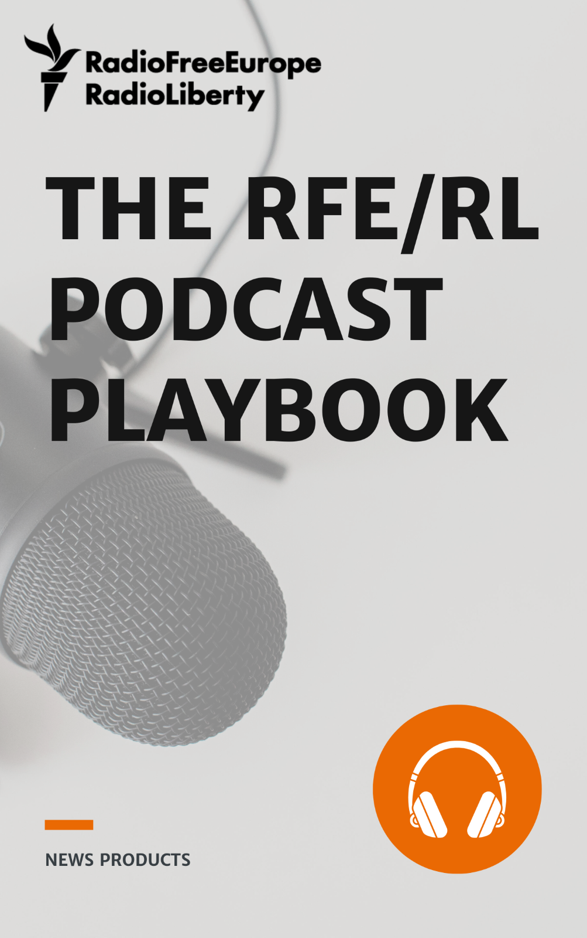

The RFE/RL Podcast Playbook

Version 2.0
Last update: 30/08/2023
Document owner: The News Products Team

How to use this playbook 3
What is a podcast 4
What makes a podcast different from a radio show? 5
Why should your team produce podcasts? 7
Four main types of podcasts 9
Interviews 11
Roundtable 11
Narrative storytelling 12
Monologues 12
Questions to answer before starting a podcast 13
How to start a podcast 16
Intro and outro 17
Soundtrack, music and sounds 18
Audio files technical specifications 21
Podcast title best practices 22
Podcast description 23
Visual identity: Podcast logo and thumbnails 24
Explainer: How to listen to a podcast 27
How a podcast article should look 28
Transcriptions 29
Podcast production and promotion timeline 30
Recording outside the studio: home office, remotely, long-distance, in the field 33
Tools & software 33
Recording setup & tips (best practices for good sound) 34
Podcast distribution: RSS feeds 36
Creating your RSS feed 36
How to set up a new podcast in Pangea 36
Podcast custom URL 39
How to set up a new episode in Pangea 40
External RSS feeds: Blockades 41
RSS specifications and changes 42
Podcast distribution: Podcast platforms 44
Apple Podcasts 46
Spotify 47
Google Podcasts 48
How to measure success 49
Reach: having impact 50
Engagement: opening a conversation 50
Loyalty: building a relationship 50
Key metrics to measure success 50
Checklist: Podcast promotion and marketing 51
Audiograms for social media 54
When to use audiograms? 55
How to create an audiogram 55
Audiograms for YouTube 60
Social audio: Twitter Spaces 66
Outdated podcasts: what to do? 72
Podcast landing page: How to set it in Pangea 73
Audience survey questions 80
Show Listening Habits 81
Listener Engagement 81
Listening Locations and Platforms 82
Episodes and Elements 83
General Podcast Listening 83
Demographics 84

How to use this playbook
This playbook defines the foundations of RFE/RL podcast production. It aims to help both first-time podcasters and experienced teams.
It's a practical guide divided into four stages: Ideation, production, promotion, and review. Each of the stages contains a series of resources to help you through the process.
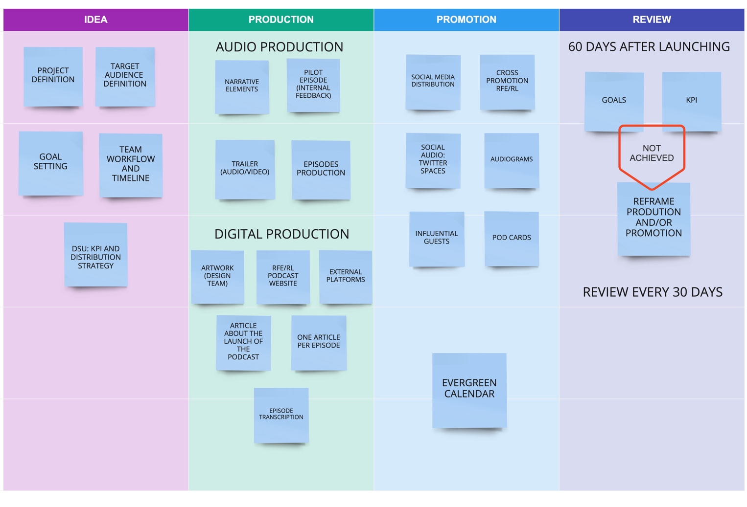
Actions are defined as Obligatory to follow industry standards or as Advanced. Depending on your team's production expertise and resources, you might choose actions from one level or a combination of both.
This playbook is a live document, and it will change and grow as RFE/RL podcast production evolves. It will accompany your team in the process of reaching new audiences and exploring new narrative territories.

What is a podcast
A podcast is an on-demand audio show you can download and listen to whenever you want. There are also video podcasts that contain videos.
Technically, to call something a podcast it must contain an audio file (mp3, AAC), be available to download, and be distributed via an RSS feed (more on podcast distribution: RSS feeds).
The origin of the word podcasting goes back to 2004 when The Guardian journalist Ben Hammersley coined the term in an article. If you want to know more, James Cridland (Podnews) has a detailed history of the word podcast.

What makes a podcast different from a radio show?
In 2018, the BBC was commissioning podcasts for its new BBC Sounds mobile app. To better explain what makes podcasts distinct from radio, they put together A cheeky list of 11 ‘commandments’ of podcasting!: (adapted from original):
- A podcast is not a radio program even if radio programs can be made available to the public as podcasts.
- For a younger generation who will never own a radio, podcasts are their radio but, reread rule 1.
- The story and topic will always be the guide for the length of a podcast.
- Podcasts are built for the headphone generation; be respectful, warm and gentle inside their heads.
- Be informal and intimate. However, the freedom to use raw language does not mean it’s an obligation.
- Podcasts are a visually powerful form of audio; they can be cinema for the ears.
- The angels are in the detail. Podcasts tell big, thorny and emotionally complex stories, real and made up.
- Podcasts offer clarity in chaos; in a manic news cycle, podcasts offer focus and context.
- Podcasts are tribal; they bond and deepen communities.
- Regardless of where they spring from, podcasts are natively global digital forms of audio.
- Podcasts are agile; they can take all the rules above and change them, except rule 1.

The debate around the differences between podcasting and radio is intense. Opinions are diverse and sometimes diverge, but there are some formatting principles that have received consensus.
Different needs and expectations
Why do people listen to podcasts? A 2022 study found podcast listeners largely expect to be entertained, to listen to compelling stories, and to learn something new, not merely to be updated.
Mobile and intimate
65% of podcast consumers listen to podcasts through their mobile device, while 25% prefer to listen on computers and 10% on smart speakers. So, podcasts are mostly consumed through headphones and earbuds, which encourage an intimate mode of listening. This is quantitatively and conceptually different from radio and facilitates a closer relationship with our audience. When producing a podcast, we are not talking to a big anonymous audience like on the radio, but to a group of engaged people that feels like a community.
Listening from the beginning
Podcast listeners tune in from the beginning, which is different from just turning on the radio. Listeners find the content and have some context (headline and description) before pressing play. They know what you are going to talk about, so podcast intros are short, go straight into the topic, and focus on arousing curiosity.
Podcast listeners know what they are tuning in to because they have made an active choice. Repetition, an essential element in radio —"You are listening to XYZ show"— is less needed.
Natural language
Podcast audiences are younger than radio audiences, and that offers an incredible opportunity to put them at the center of our content and fulfill their expectations about the format.
A podcast should feel cozy, as if the listener were invited to a conversation in a bar. There is no need to edit silences or pauses because they are part of how we naturally speak and are narrative resources. However, be careful of filler words and vacillations, as they can break the narrative flow.
No time constraints
Podcasts do not have the scheduling constraints of broadcast media. Podcasts commonly last 20-30 minutes, or the average commute time in major cities. That said, there are all kinds of exceptions: News briefings podcasts (NPR Up First, FT News Briefing, WSJ Minute Briefing) can be five to 10 minutes long, deep-dive interviews like Joe Rogan Experience that lasts up to three hours, or the Die Zeit podcast Alles Gesagt that can take up to six hours.

A podcast is meant to be listened to by the audience whenever they want. It is distributed via RSS feed. Podcasts are mobile and built for the headphone generation.

Why should your team produce podcasts?
The popularity of podcasting differs depending on which part of the world you live in. The Reuters Institute Digital News Report 2022 found that in the 43 countries they surveyed around the world, 34% of respondents consumed one or more podcasts in the last month.
In the U.S., the Edison Research Infinite Dial survey (2022) found that 38% of respondents listened to a podcast monthly while 62% had listened to a podcast at least once.
The most-listened to news podcast in the world — The Daily by The New York Times — has over four million average daily downloads, and each podcast article includes a link that takes the audience to instructions on how they can listen to the podcast. .
That The New York Times has need for an explainer points to the state of podcasting in the world: Many people are listening to shows, and many more have heard of podcasting or even listened to an episode; still, a lot of people don’t know how to listen to podcasts or why they should.
There is good news: Most podcast listening happens on mobile phones, and all have a native podcast player. Apple Podcasts is on all iPhones, and the Google Podcasts app is available on Android devices. And with more than 430 million global users, Spotify is a major force in podcasting as well.
YouTube and Twitter are adding podcast features to their platforms, indicating the huge potential of the format among younger audiences, especially.
If podcasts haven't caught on in your country, you have an incredible opportunity to lead the market, because your audience already has the tools to become a regular podcast listener. Now it's your turn to deliver a compelling podcast they want to listen to and show them how to enjoy the format.

Podcast is now a well-known term, but that doesn’t mean everyone knows how to listen to one and what tools (apps) they need to use. Always add explainers to your podcast articles.

Four main types of podcasts
There are all kinds of podcasts, and you could probably classify them in a million different types and categories.
The podcast industry is mainly driven by the categories and subcategories introduced by Apple Podcasts.
- Arts  - Books  - Design  - Fashion & Beauty  - Food  - Performing Arts  - Visual Arts  - Business  - Careers  - Entrepreneurship  - Investing  - Management  - Marketing  - Non-Profit  - Comedy  - Comedy Interviews  - Improv  - Stand-Up  - Education  - Courses  - How-To  - Language Learning  - Self-Improvement  - Fiction  - Comedy Fiction  - Drama  - Science Fiction  - Government  - History  - Health & Fitness  - Alternative Health  - Fitness  - Medicine  - Mental Health  - Nutrition  - Sexuality | - Kids & Family  - Education for Kids  - Parenting  - Pets & Animals  - Stories for Kids  - Leisure  - Animation & Manga  - Automotive  - Aviation  - Crafts  - Games  - Hobbies  - Home & Garden  - Video Games  - Music  - Music Commentary  - Music History  - Music Interviews  - News  - Business News  - Daily News  - Entertainment News  - News Commentary  - Politics  - Sports News  - Tech News  - Religion & Spirituality  - Buddhism  - Christianity  - Hinduism  - Islam  - Judaism  - Religion  - Spirituality | - Science  - Astronomy  - Chemistry  - Earth Sciences  - Life Sciences  - Mathematics  - Natural Sciences  - Nature  - Physics  - Social Sciences  - Society & Culture  - Documentary  - Personal Journals  - Philosophy  - Places & Travel  - Relationships  - Sports  - Baseball  - Basketball  - Cricket  - Fantasy Sports  - Football  - Golf  - Hockey  - Rugby  - Soccer  - Swimming  - Tennis  - Volleyball  - Wilderness  - Wrestling  - Technology  - True Crime  - TV & Film  - After Shows  - Film History  - Film Interviews  - Film Reviews  - TV Reviews

There are many categories, but four main types of podcast formats:

Interviews
The most common type of podcast and one of the most used by news publishers is an interview show between two or more people.
The format is an all-time newsroom favorite. However, don't think of it as the classic Q&A journalistic exchange, but rather as a conversation where there is a natural dynamic between the host — their personality is essential — and the guest(s). The keys here are connection naturalness and authenticity.
With an interview podcast, bear in mind how many guests you have and how long you want the podcast to be. For a 30-minute episode, one guest will give you enough time to delve into the topic.
If you have two or more guests in a 30-minute show, they won’t have enough time to unpack the topic. A good rule of thumb: One guest 30 minutes, two guests 45 minutes, three guests 60 minutes.
Your podcast strategy will get off the ground if your guests are names that people want to listen to or if they have surprising stories to share. (Advanced)
Interview shows are very popular, but competition is fierce: If you look at the top podcasts (let’s use the U.S. as an example), most of the shows in the top 10 are interview shows.

Roundtable
In roundtable podcasts, one or two hosts present topics to a panel of guests, creating a conversation with multiple viewpoints and personalities. Ideally, the result sounds like an organic conversation among friends or colleagues.
The roundtable format is ideal for opinions, debates, and predictions. Vox's Worldly and BBC Newscast are good examples.

Narrative storytelling
Narrative storytelling means there are one or more storytellers narrating how certain events unfolded. Production of this format can be as simple or as complex as the team's resources and expertise allow.
The narrative storytelling podcast label includes a wide range of podcast types and genres (true crime, investigative reporting, human stories). This American Life, Lore and Radiolab are among the most-listened to narrative podcasts and a good reference for audio professionals. Each has a distinct style, and each reflects the production capabilities of its creators.
Of the four basic types of podcasts, narrative storytelling requires the biggest investment of time and money. In some cases, seasons are planned months before their launch, with most episodes already recorded when they start to be published.
Narrative storytelling is driven by creativity and experimentation, and there are no constraints on length or structure. To make it work, however, requires planning and thinking thoroughly about the content.

Monologues
The fourth type of podcasts are monologues. These can be highly produced and resemble a narrative storytelling podcast; some of them are a crossover between the two types.
One example of a popular monologue-based podcast is Dan Carlin's Hardcore History, where the author talks for three to five hours about a historical topic.
Monologue-based podcasts don’t have to be long. Some news organizations use this type to create a shortform news podcast with just one anchor reading the most important news of the day. One episode usually lasts five to seven minutes.
Another type of show that relies on monologue is news commentary or a summary like the Techmeme Ride Home podcast, which takes the most important technology news of the day and summarizes the top stories for the listeners.
Each type of podcast has its advantages and disadvantages. It's important to think carefully about our listeners' needs and our goals before choosing one.
There are many podcast categories, but these generally fall into four broad types - interview, narrative storytelling, roundtable, and monologue. Interviews are the most common and usually the easiest to produce.

Questions to answer before starting a podcast
In the same way that images projected on a big screen are not cinema, an audio file on Spotify is not a podcast. To find out whether an idea has the ingredients to become a podcast, you need to interview your idea. This questionnaire will help you to prepare the pitch (Obligatory) and refine the project.
Once you have checked the idea is consistent, you are ready to pitch it to your editors and Service director.
After your Service’s approval, send the questionnaire to the News Products Team (pedretalcarazc@rferl.org) (Obligatory), who will assist in audience definition, consistency, timeline, and KPI (key performance indicators).
Questionnaire (Obligatory)
The questionnaire is adapted from the NPR Project Blueprint and the GLAFT model (Goal, Attraction, Format, Technology and Listeners) introduced in this Reuters Institute fellowship paper.
The project
- What are you calling the project? List three possible names.
- Describe your project in one memorable sentence (elevator pitch + statement of purpose). Max 180 characters.
- What is the show going to look like:
  - Podcast type: interview, narrative storytelling, etc.
  - Number of episodes and duration.
  - How many hosts and team members do you need?
  - How often will you publish new episodes? Ideally weekly (Be realistic about your team's workflow).
- List topics and possible headlines of your first five episodes to check variety and topic consistency.
- Do you have something special for the end of the show to keep listeners engaged until the end? (Final fun fact, results from listener poll, answers to listener questions, etc.)
The audience
- Who is going to listen to this podcast? Be specific (Ex: early-career millennial women). If you define several audience groups, choose one or two and focus on them. The remaining groups will be supporting audiences.
- How big is the estimated audience for this podcast? If it's too small and narrow, you need to rethink your approach.
- What might your audience need from the project?
- Why are they going to come back to the show? (Recall the top three reasons listeners follow a podcast: to be entertained, to listen to compelling stories, and to learn something new.)
- What unique value and perspective can you add to your audience’s lives? (Novelty)
- Where else might the audience get this information (from you or from your competitors)?
- How might audiences benefit from the project? Will it:
  - Inform or empower them?
  - Inspire them to take action?
  - Connect them to other people?
  - Improve their lives or change policies?
Your goals and your digital strategy
- How do the goals of the podcast fit into your Service’s broader goals and target audiences?
- How are you going to engage with the listeners? Social media, polls, voice messages with listeners' questions, etc.
- What does success look like? Ex: Number of subscribers; minutes listened to; page views; number of stories produced from podcast material... (for more, see the How to measure success section)
- What obstacles do you anticipate and how will you overcome them?
Add the details of your project inside the [brackets] to have a complete picture of your idea.
[PROJECT TITLE] is a [FORMAT]
that [KEY BENEFIT] for [AUDIENCE]
who [NEED/OPPORTUNITY].
Unlike [ALTERNATIVES/COMPETITORS] our project
[ADVANTAGE/STRENGHT].
Download the questionnaire.

Take advantage of what you already produce
It's exciting to create something from scratch, but before you do that, consider whether you are already producing content, either for radio or on video, that is suitable for podcasting.
An interview-based video or TV show is ideal to become a podcast. Many newsrooms work on repurposing one type of content into others. This is especially important for audio, as it’s hard to distribute on social media.
Open as many entry doors as possible to your podcast using other easier-to-share formats such as video, text or images (more on that in the podcast promotion section). You can publish — one might even say “should” publish — the original video-based interview show, then take the audio and publish it as a podcast. Many newsrooms increasingly go for transcriptions of such interviews, and they become articles (more on the myth of cannibalization in media).
After you have audited your existing content —bearing in mind the format particularities —, you can think about creating original podcasts answering the questions above.
Production can be the other way around: A podcast can be on the radio. Depending on the case, you would only need to change your intro slightly.

How to start a podcast
After your idea is defined (Questionnaire) and approved, it’s time to jump into the production process. There are two main working lines: Audio production (scripts, recording, music, audio edition) and digital production (images, headlines, descriptions, articles, transcriptions, promotion, etc.).
A current events podcast is different from a podcast about mental health, but the sooner you start planning, the better. For small teams, it can be a game-changer to have two or three episodes finished — or even more — when the first episode is officially launched.
*Note on equipment
Before doing any recording, contact Broadcast operations to get advice on the best equipment for your project.
Send your request to bookings@rferl.org, including a brief description of what you are producing and the type of support you are requesting — equipment or operational support. Studio or sound operators’ requests should include duration.

Contact Broadcast operations to get advice on the best equipment for your project (Obligatory)

Audio production (Obligatory)
- Intro / Outro
- Soundtrack, music, and jingles
- Script/s: Podcast structure
- Trial: Record a complete episode for quality control and internal feedback
- Trailer
- Non-current affairs podcasts: Ideally two or three episodes pre-produced before the launch (Advanced)

Intro and outro
Each podcast has its own character, but it's important to identify them with your Service. We create this association by using the podcast logo (visual), the intro and the outro (sound).
In the intro, the host should say his/her name, the name of the show, and the name of the Service , i.e. Radio Svaboda, Szabad Európa, Europa Libera, etc. The order can be changed.
"This is XYZ from [Service name]. I'm Maria Smith"
"From [Service name], this is XYZ. I'm Maria Smith"
You don't always have to start the same way. You can start with a surprising quote, a shocking headline, give the audience some context and then add the intro's information:
"Why has this happened and what are the consequences? From [Service name] this is XYZ. I'm Maria Smith."
If the podcast is not about hard news, the host can even say "Hello" to reinforce the conversational feel:
"Hello, I'm Maria Smith and this is XWZ from [Service name]"
If you are planning to launch a new podcast, the intro of an existing show is a good place to promote it.
The outro should be an invitation to continue listening. You can reveal some content of the next episode, invite your audience to connect with you on social media, and encourage them to subscribe to your newsletter or leave a review on external platforms. It should be a call to action to increase loyalty and connection.
Your outro should always include a "thank you note” and, from time to time, a reminder about where people can listen to your show:
“I'm Maria Smith. This is XYZ from [Service name]. Thanks for listening"
“I'm Maria Smith. Subscribe to XYZ from [Service name] whatever you get your podcast. Thanks for listening!”

Soundtrack, music and sounds
Music and sound are key elements of a podcast. Before choosing them, you need to define the mood of your show. Is it a “newsy” and “flashy” fast-paced podcast where you need 100% of the listener’s attention every few seconds? Or is it a story-based longer format that needs to deliver a certain feeling?
You need to ask yourself these questions to pick the right music for your podcast. If you are not sure and need some inspiration, listen to podcasts about similar topics. You can forward these to make it easier for the sound producer to produce something.
Music is protected by copyright; under a few seconds or heavily remixed samples are no exception. The same principle applies to video podcasts.
We must own the copyright rights of the music we include in our podcasts. One option is to use Hudebni Banka as your primary resource to find songs and jingles. The primary point of contact for the platform is Darab Gajar.
How to use Hudebni Banka
If you have more time and resources, a second option would be to hire a composer or a musician to create custom-made podcast music, intro, outros, trailers, etc.
Podcast music/soundtrack essentials (Obligatory):
- Intro music
- Background music and sounds
- Transition sounds (jingles)
- Outro music
Your intro should have some music. The best practice is to start with the beginning of the song you picked. Try to fade it to background music, a loop or fade out after 5-10 seconds. It does not need to be long; you just want to set the mood of your podcast with it.
If you do not like the beginning of the song you picked, find a part with a small onset or create a fade-in at the start. You do not want to start your podcast with a loud sound; make it smooth and pleasant for the listener. If you have custom-made podcast music or many versions of the track you liked from a paid service, try to make those about 5-10 seconds long.
After the intro, you can either start the spoken word without music or fade the intro into some quieter background music or a loop. With background music, you can continue with the track after the intro segment. Just make it quieter so that the voice in front of it sounds clear.
You can also use a different part of the track as background music; just be sure it connects right to your intro. If there is a part you like, but your voice intro is much longer, find a part where the track can be repeated and loop it in a row for as long as you need.
When this whole intro segment with background music ends, you can close it with a fade-out or a transition sound.
As a transition sound (jingles), select a short sound or part of a track you picked. You can make it snappy, for example 2-5 seconds long, just to change topic or move to another subject in your podcast. If you need to create some tension, drama or emotion, you can make it longer—even up to 10-15 seconds—and let it fade out. If you like, you can have more transition sounds for different purposes.
You can use your transition sounds after the intro, between topics or segments in your podcast, or before outro. If you have unique podcast music made for you, or many versions of the track you liked from a paid service, make those about 2-15 seconds long and use them at the right time.
The final element you need is an outro. Choosing the right outro is similar to choosing the intro, just in reverse. You can close out your podcast with the ending of the track you picked. Be sure to use a little fade, transition sound, or some background music before it.
Even if you do not choose the original ending of the track and instead pick a part you like yourself, bear in mind that this is the end of your podcast and there is no need to rush it. Let the background music play behind the voice and let the music (and podcast) finish with a long fade-out. You can make the outro segment 15+ seconds long, but best to keep it under a minute.

For content transformed into podcasts
With radio shows, video shows or other content like Twitter Spaces that you would like to publish as a podcast, you can use the same sound and music elements as in the original content.
It is not advised to use the audio without acknowledging that the content wasn’t produced originally as a podcast. That way, listeners know the content was not intended solely to for that purpose and will forgive you if you point to something visual that they cannot see.

Trailer (Obligatory)
The first audio content a listener will see when they click on your podcast is the trailer. A good trailer should be around 60-90 seconds long and introduce the host and the project. It can be a separate recording, or it can be a compilation of the best moments if you already have some recordings.
The trailer should be dynamic and leave the listener wanting to know more. Use the same music and sounds that you plan to use in your podcast to show your personality and give listeners a flavor of what the podcast will sound like. Remember to ask listeners to subscribe.
Some examples: Putin (BBC radio 4), The 7(The Washington Post)
A trailer needs to include the following information:
1. What your show is about and who you are
Let your audience know what and whom they’re listening to and briefly explain what your show is about.
2. What the listener experience is like
Describe what kind of podcast you are producing (conversations, stories, daily news, etc.) and connect it with your audience’s needs. Find the moments from your show that define what the listening experience is like. If you already have some recordings, include quotes or best moments. If you tell stories, lead with details that help establish your narrative.
3. Coming back
There are hundreds of podcasts out there and your trailer is the opportunity to show how you are different. Build some tension and curiosity, for example, by leaving an unanswered question that will be answered on your episodes.
4. A call to action
Make sure listeners know when and where they can find new episodes, and don’t forget to mention that they should subscribe.
Depending on your resources, you can use the audio trailer to create a video trailer (Advanced) as part of your promotion strategy on social media and, especially, on YouTube. An audiogram is the simplest option, but the biggest production companies make cinematic trailers to promote their new podcasts.

Audio files technical specifications
Exporting a file from David (Diga System)
When exporting your audio file from David, put the cursor over the title of your recording > right button > convert audio.
Choose the following parameters:
- Audio format: MPEG Layer 3
- File format: Broadcast-Wavefile
- Total bit rate: 128 kBit /s
- Sampling frequency: 48 kHz
- Mono
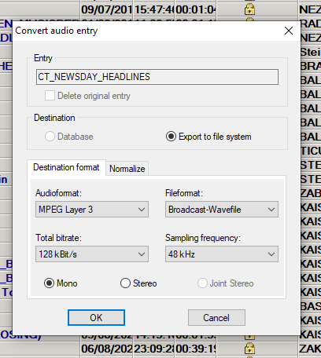

Exporting a file from another audio editing tool
If you are using a different audio editing tool, such as Audacity, Adobe Audition or other, for podcast audio purposes choose the following parameters:
- Export file > .mp3
- Bitrate of 128 kbps and 48 kHz
- Mono output

Digital production (Obligatory)
Apart from the scripts, the music and the audio recording, you will need to put together additional information and digital materials to build your podcast website.
- Title
- Description
- Logo / thumbnails / audiograms (artwork)
- Custom branded header for your website
- Type (episodic or serial)
- Explainer: how to listen to a podcast
- Article about the launch of the new podcast
- New article for each episode
- Episode transcription (Advanced)
* Author, e-mail, website link, language of the podcast and location are generated automatically by Pangea, although if you were setting up a podcast on a different podcast hosting platform like Buzzsprout, you would need to fill these in as well.
** In the system settings in Pangea CMS, the author of the podcast should always be the Service: Radio Svaboda, Szabad Európa, etc. and not RFE/RL as that brand is not recognized, but the regional service name is.

Podcast title best practices
There are no limits to the imagination when it comes to your podcast name. However, the best titles are short and catchy: Catchphrases or puns work very well.
The title should be something memorable that sounds good when you say it. You can find some inspiration by checking the names of podcasts that top the charts.
Before choosing a name, make sure it hasn't already been used, and check for similar projects and competitors.
Don'ts
❌ Don't include the word "podcast" in the title. This is counterproductive, will downrank your podcast, and make it less unique and harder to find. Think about it as if the word "film" were included in the title of a movie.
❌ Don't include the name of your Service in the title. This is counterproductive and repetitive, as the name of your Service is or will be included as the author of the podcast. Think about it as if the name of a studio, for example Warner Bros, were included in the title of a film they produce.
❌ Don’t put the author/host of the podcast in the title.

Podcast description
In addition to the title and the author, the listener will see a description of your podcast. It should include what your podcast is about, who the host is, what topics you will cover, why people should listen to it, and how often your podcast is released.
Description guideline (order is changeable depending on relevance):
- First sentence: A powerful statement that connects with your listeners’ needs and beliefs and creates curiosity.
- Second sentence: What the podcast is about and what your listeners can expect.
- Third sentence: Who is the host and when and how often the podcast is published.
Example from The Daily (The New York Times)
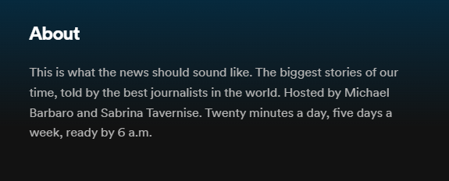
Podcast APPs only display part of the description (Spotify 120 characters, Apple podcasts 150 characters); to read the rest, the user must click a ‘see more’ button. That is why it is important to start your description strong and with intention so that the listener wants to know more and, ideallly, starts listening to your podcast right away.
The description will help listeners find the podcast, so it is essential to include keywords about its content. As in the title, there is no need to include the word "podcast" unless you can say things like "first podcast in Hungarian.”
Always close the description with a full stop.

Visual identity: Podcast logo and thumbnails
Even before listeners notice the name and description of your podcast, they will notice your logo. Most podcast platforms rely heavily on visuals, so images are an important ally to lure your audience.
The optimal logo size should be 3000 x 3000 pixels, in JPEG or PNG format. Don't forget that people listen to podcasts almost exclusively on mobile, so your logo will be displayed in small formats on small displays. Consider that when composing objects or photos in the logo, but also when choosing the font size.
Small size text and cliché images such as headphones or microphones are considered bad design practice.
How to request the artwork for your podcast:
- Open a ticket as a Graphic / Infographic request and fill in this form for each new podcast. Contact Karel Knop or Zdenka Plocrova (Pangea Design Team) if you have any questions or need assistance
- The Pangea Design Team might schedule a meeting to clarify the request
- Second meeting to review the artwork and give your feedback (at least one week after the first meeting)
- Artwork delivery

RFE/RL Podcasts Graphic Guide
Basic rules (according to RFE/RL internal guidelines)
- Artwork should be simple and easily recognizable (keep in mind mobile devices where graphics will be very small and tiny details get lost)
- Include your podcast title (ideally as short as possible)
- Use relevant imagery
Four types of graphics
1. Text only
- Recommended for long titles
- Use of vibrant plain colors and bold texts
- Maximum of 3-4 words / 15 characters

2. Graphics / Illustrations
- Tell a story through visual metaphors and simple elements
- The graphics should not compete with the text of the title
- Do not use too many colors
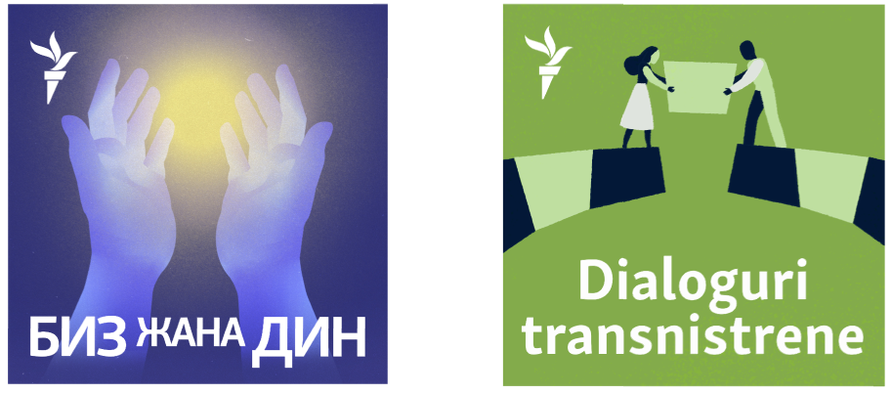
3. Portrait (personality driven)
- Portraits should be placed on a simple background color or gradient

4. Images
- Simple images with few elements
- Images must have space for the text

Other Examples:
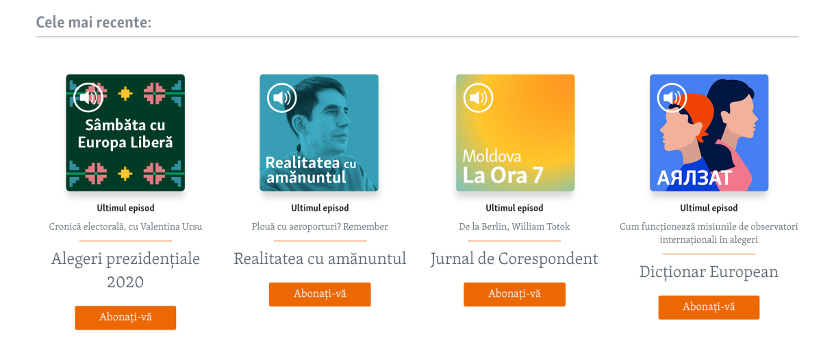

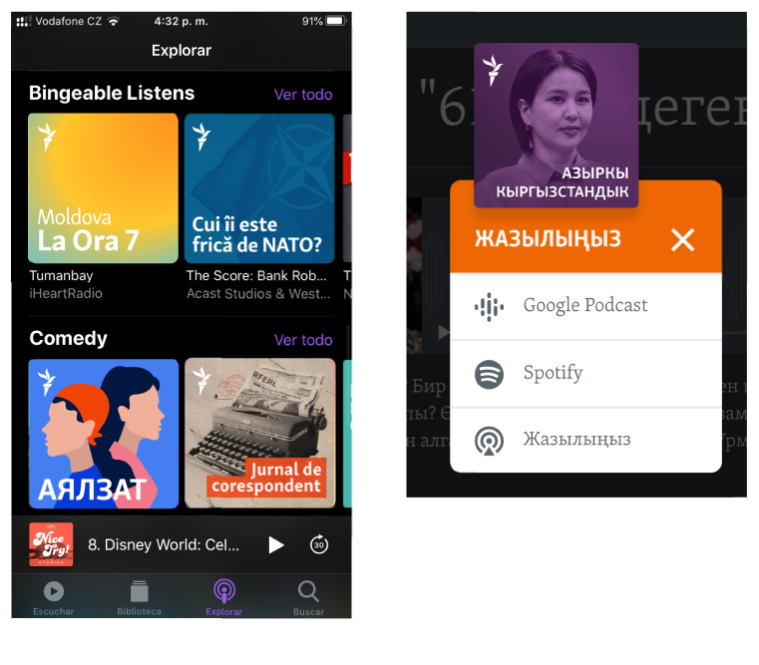

Custom branded header
Podcast pages need to have a custom branded header (Obligatory).
Ask the Pangea Design Team to adapt your logo or follow the color range. Once you have it, open a ticket to ask the Pangea Team to add it to your podcast zone.
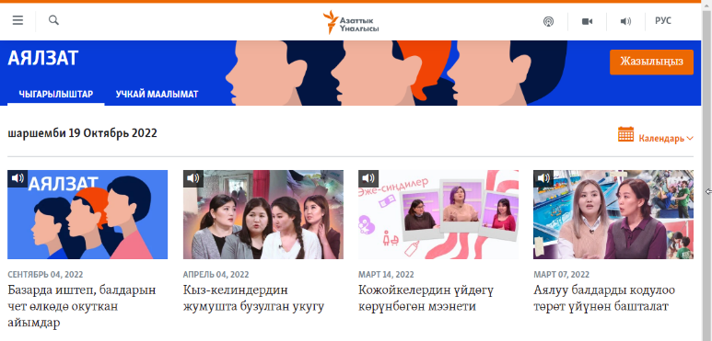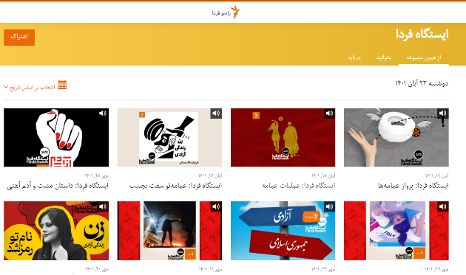

Explainer: How to listen to a podcast (Obligatory)
It’s important to help the audience find your show. Your Service should have a template explaining where and how listeners can listen to the shows.
A link to the explainer should always be included in the podcast website and in all the articles related to the podcast. Your Service does not need to write it every time but make a copy and include the specific links to Spotify, Apple Podcast and Google Podcast of your new show.
Here is an example of an explainer by The Daily.

How a podcast article should look
After you publish a new podcast episode, a page for that episode will be created with the player at the top and podcast description underneath. It will look like this. You can add custom text with links if you like. On Pangea, remember to add links to Spotify, Apple and Google podcast.
For better discovery and to get non-listeners to consume the podcast content, we recommend creating a separate article with the embedded audio of the podcast episode. The article can be about the topic of the podcast and/or the whole transcript of the episode, for example, in the case of an interview. You should have at least one of these formats, either an article (Obligatory) or a transcription (Obligatory), and ideally both if you have enough resources (Advanced).
Here are two examples:
- «КРАСАЎЦЫ». 9 жніўня — прэм’ера падкасту Свабоды пра вайну сілавікоў супраць беларусаў у 2020 годзе (svaboda.org)
- Da li biste prijavili rupu na cesti? (slobodnaevropa.org)
These kinds of articles index better on Google searches because they contain more keywords. This means that random visitors will stick around longer, opening an opportunity to promote to audiences who may not have come for the audio experience.
Podcast article elements
- Headline
- Description
- Image
- Podcast player: The higher in the article, the better (audio file download link is part of the native audio player)
- Links to main podcast apps: Apple Podcasts, Spotify, Google Podcasts, RSS feed link
- Link to the podcast page with all the episodes
- Link to the explainer article: How and where listeners will find your podcast

Transcriptions
One of the best practices to boost podcast discovery on search engines is having a text version of your podcast—a transcript. You need to support your podcast with some text; this can be an article about the topic of the episode (Obligatory), a transcription (Obligatory), or both (Advanced). Whatever your choice, be consistent and stick to it for your entire podcast season.
Transcriptions are an excellent way to introduce your podcast to audiences that are unfamiliar with podcasts. People find it easier to listen to stories than to read them, so giving both options increases your chances of getting more people to tune in.
Some Services are already transcribing podcast interviews and publishing them as plain text. Here is an example from the Szabad Európa Szelfi podcast.
How to transcribe audio
As part of your Microsoft Office 365 access, you are given 300 minutes of free transcription credits each month. You can access it via Word. Just open Word online, start a blank document, find the microphone icon in the menu, and choose Transcribe.
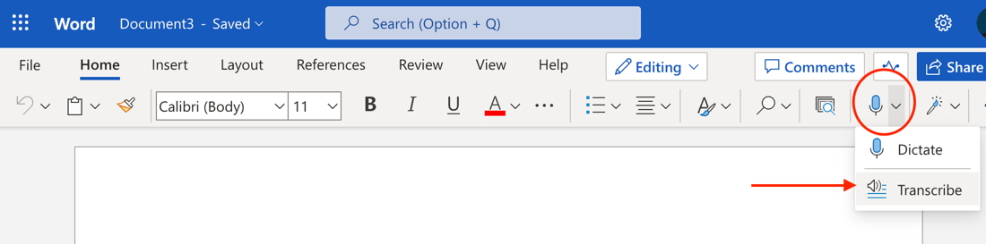
Then choose the language of the audio and select the audio file. After you select it, Word will automatically start transcribing the audio. Some languages still need editing, as the transcription is not as perfect as in English. You can then choose to include the transcription in the document with speaker names and timestamps (if you want to use the transcription as captions) or leave it out.
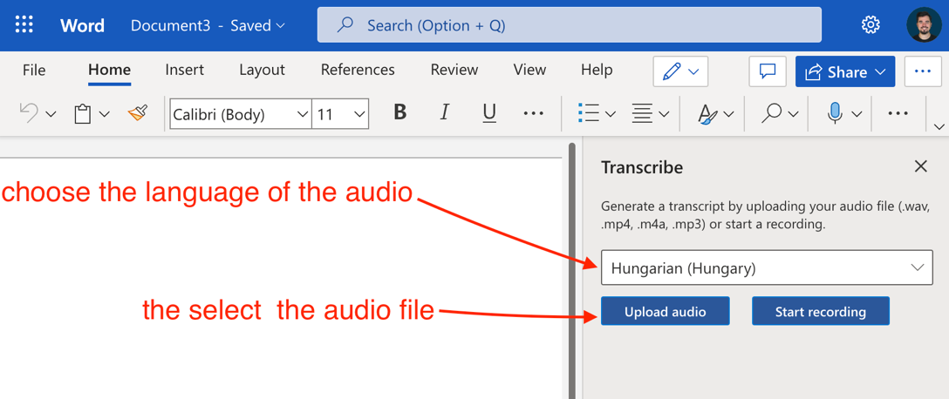
There are many transcription tools, but they are not free. If you need to use third party tools, Trint and Happy Scribe are among the best ones out there.

Podcast production and promotion timeline
To create a holistic podcast strategy, we advise each Service to designate a person to monitor the podcast production. This person might be a digital lead, unless an audio lead is defined. The lead will:
- Check the e-mail associated with the podcast RSS feed and take action when needed.
- Control the promotion timeline and digital materials preparation in coordination with teams, editors and the News Products Team.
- Write the How To Listen to a Podcast explainer and edit it for every new show, adding links to external platforms.
- Report technical issues to the News Products Team.
- Coordinate with the News Products Team to share ideas, check podcast performance, and change the strategy if needed.
- Check reviews on external platforms.
- Create a calendar to promote evergreen podcasts.

Timeline
You have your podcast ready: When should you start spreading the word? A good rule of thumb is to start publicly talking about your new podcast only when it is available on the three major platforms: Spotify, Apple Podcasts and Google Podcasts.
Make sure that everything works and that your podcast is accessible from each of these three platforms. This is crucial because you are building an audience who primarily listens to podcasts via one of these large platforms.
The earlier you plan your project and your strategy, the better.
Four weeks before launch:
  - Decide on a tentative launch date.
  - Deadline to choose your podcast name.
  - Draft of your distribution and promotion strategy with News Products Team assistance.
  - Commission the artwork with the Pangea Design Team. You will need (Obligatory):
      - A podcast image
      - An audiogram template with the podcast image (optional)
      - Website images (custom branded header, horizontal, etc.)
      - Thumbnails for YouTube (Obligatory if it's part of your strategy)
Three weeks before launch:
  - Set a definitive launch day (avoid weekends) and time (recommended time 5 AM to 6 AM).
  - Deadline to decide your intro/outro structure and the elements to build your audio personality (jingles, music, effects).
  - First draft of podcast logo and website images to review.
  - Current events podcast: Try a pilot episode and collect internal feedback.
  - Non-current events podcast: Your first episode should be finished to collect internal feedback. Your second episode should be on the production line.
  - Start working on your trailer. You can have only audio (Obligatory) or audio + video (Advanced).
Two weeks before launch:
  - Make final changes to your first episode based on feedback. Small teams or teams producing non-current events podcasts should think about launching the podcast with at least two episodes finished.
  - The Pangea Design Team delivers the podcast and website images.
  - Finish the trailer before publishing the podcast website.
  - Create the podcast page in Pangea (the how-to is in the next section), add all the information regarding your podcast (images, description, details) and publish it.
  - Upload and publish the trailer as an audio clip to get the Pangea RSS feed.
  - Send the RSS feed—it will include only the trailer—to the News Products Team so it can be submitted to external podcast platforms (2-4 days).
One week before launch:
We are in the promotion phase. The goal here is to build hype and get the first subscribers. But first, you need to settle a couple of things:
  - Check that the links to external platforms work and add them to Pangea to make the icons visible on the podcast website.
  - Write an article saying you are preparing a new podcast, what it will be about, why people should subscribe, where (links to external platforms), and who is the host. Embed the trailer so that listeners can get a taste. Think of it as a kind of press release (Obligatory).
  - Write and publish an article about how and where listeners will find your podcast, with links to all the platforms where it is available, and how to listen to podcasts in general (Obligatory).
  - Spread the news on social media. Use an audiogram with the trailer (more on how to create audiograms), the link to the podcast website, the podcast logo, and the article about the podcast launch and where to find it. If YouTube is part of your distribution plan, publish the trailer there as well.
  - Create a social media publication calendar for every new episode that sets time, day and publication platform.
  - Write an article (don’t publish it yet) about the topic of your first episode that includes:
      - An embedded audio player with the first episode
      - Links to Spotify, Apple Podcasts and Google Podcasts (Here is an example)
      - A link to the article about how and where to listen to the podcast
  - Transcription: You can have an article per episode, a transcription, or both, but be consistent with your choice. Stick to it.

Think about other products of your Service (newsletters, programs, podcasts) that share your target audience, and cross promote the launch of the new project (Obligatory). You can include it in your newsletter or drop the trailer in the feed of an existing podcast with some explanation that there is a new podcast you recommend.
You can also insert a short ad based on the trailer in the intro of an existing podcast episode or radio show.
Launch day
- Publish the first episode (you will schedule it).
- Publish the article and/or the transcription for your episode.
- Follow your social media calendar.
The host and RFE/RL journalists are essential to the promotion strategy, especially if they have a large number of followers. Contact those people in your Service connected to the topic or the region to help spread the word.
If the podcast has content that does not expire (evergreen content) or there are events related to your podcast topic, think about promoting your episodes or the entire project months after it is finished. Bear in mind your audience’s habits and when they have time to enjoy the content.
❗️ Remember to schedule your episodes early in the morning (5 AM-6 AM) and avoid weekends.

Recording outside the studio: home office, remotely, long-distance or in the field

Situations
- Recording yourself working from a home office
- Recording an interview with a remote guest from home
- Recording an interview with a guest on a remote location
- Recording a field interview (not great connection, max 2 devices, microphone)
- Other remote locations with limited access to devices and professional microphones

Tools & software
MS Teams
- When both parties are on a good internet connection, you can setup a call/online meeting within Teams and also invite outside guests to join
- Teams offers a recording function and will even transcribe the interview afterwards (read more in Transcription, page 29)
Online recording apps for podcasters
These apps record locally and then send the audio recording to the cloud, meaning the audio quality is better.
- Riverside.fm - let’s you record for free, but you only get a single file, meaning the audio tracks are already mixed together, for $15/month you can get separate files (also records video)
- Zencastr.com - 2 hours of separate track recordings for free or more from $18/month (also records video)
Apps
- Use a basic recorder app on your smartphone
  - Microphones in high-end smartphones got fairly good over the years
  - To record yourself, just open a native app on your device and speak into the mic
  - If you are on the call, have no external mic and need to record yourself, just make the call from another device and use your smartphone as a microphone
  - Google’s Recorded on Android
  - Voice Memos on Apple iPhone
- For situations when you have an external (USB) mic from the newsroom:
  - On a Windows computer, use the Voice Recorder app available for free (here’s a guide)
  - On a Mac computer, use QuickTime Play that’s also built-in (here’s a guide)
Note: Try to avoid recording an interview or even someone for a short comment over a normal phone call, the quality ends up being bad. Try to get your source to use their own recorder app or set up a call for them.

Recording setup & tips (best practices for good sound)
- Make sure you and your guest(s) have a strong internet connection.
- Ensure both parties have a quiet recording space (or as quiet as possible).
- Wearing headphones or earbuds is recommended to eliminate audio bleed (to prevent any unintended noise to get picked up by your microphone).
- Minimize background noise by applying DIY acoustic treatments to walls, or filling the room with furniture and rugs to absorb reverberant noise. A good practice is also to surround yourself with pillows in a home office.
📍 Important note: Make sure you and your guests have tested your recording setup beforehand including recording a test audio and listening to it. There is nothing more frustrating than finding out you didn’t record correctly or that a cable is buzzing during the whole time you are speaking.

1) Recording yourself working from a home office
- Pick up an USB-mic from the newsroom.
- Connect the USB-mic and open up the recording app.
- In the recording app, make sure you have chosen the right input, that being the mic you just connected to the computer.
- Test the recording and make the adjustment.

2) Recording an interview with a remote guest from home
Again, don’t forget to pick up an external USB-mic from the newsroom. Because you have guests, you will need to make sure everyone has the right setup, which is:
  - An external USB-mic
  - Headphones
  - Good internet connection
You should test all of the above beforehand with the guests.
- If the guests don’t have an external USB-mic, make them send you a recording from the mic they planned on using (usually they will go for the built-in mic on their computer, mobile phone or the mic in their headset – some of these can sound OK, but usually their sound quality is not good enough.
- If the mic they planned on using isn’t good, suggest to them using the mic on their smartphones. Simply instruct them to put the phone in front of them on a bunch of books or a box to be closer to the mouth, open the recorder app and hit record.
Note: They need to make the call with you from a different device and also use headphones otherwise your voice will leak through to their recording.
Even big international newsrooms such as The New York Times are using this technique to record audio.

3) Recording an interview with a guest on a remote location
Going to interview a guest on a remote location requires more preparation and knowledge of the place you will meet your guest.
- You should still try to find a reasonably quiet place.
- Also, your guest is most likely no going to have a computer and a mic, so you need to bring two mics and a digital recorder, something similar to the Zoom H4 Handy Recorder, to which you can connect two external mics for you and the guest (if there are more guests, you can make the share the mic).
- In case you find yourself in this situation without proper equipment, you can use both of your smartphones are mics and use the native recorder app on the phone to record your voice. Don’t forget to ask the guest to send you the recording immediately.

4) Recording a field interview (not great connection, max 2 devices, microphone)
- Same as in 3), you just need to be prepared to move during the interview. In that case, try to get wireless mics beforehand.
- Also, you can both with your guest use your phones as mics. The important thing is to make sure your guest has his mic close enough, but not too close, not to ruin the recording.

5) Other remote locations with limited access to devices and professional microphones
- In any other situation, you have to try your best to get the most acceptable audio quality.
- In these situations, going straight to record on a device like smartphone you and your guests have, is the best solution.

Podcast distribution: RSS feeds

Creating your RSS feed

To get your podcast audio to your listeners, you need to distribute it via platforms such as Apple Podcasts, Spotify, Google Podcasts, and others. The audio is not stored on these platforms; they are merely aggregators where listeners go to listen to their podcasts. Think of it as social media—you post links to your websites and audiences find them, click on them, and then get to your content.
RFE/RL has its own podcast hosting platform within the Pangea CMS, where the audio is stored and distributed via the RSS feed. Thanks to the RSS, podcasting is open, which means that once you create a podcast, an RSS feed containing all the information regarding the podcast is generated. If published on the web, anyone can take it and add it to a “podcast catcher”. That’s how it is distributed, found, and consumed by the audience.

How to set up a new podcast in Pangea
The team producing the podcast or the digital/audio lead will set up the zone for the new podcast in Pangea.
Follow these steps to open a podcast zone on Pangea. And see here for more details.
Specifics to bear in mind when opening a podcast zone:
- Program Pages > Select Radio
- Fill in the title and description, and upload the logo and horizontal image
- Enable content type: Audio
- Podcast enabled (very important)
- RSS enabled: Check this option only if you have articles
- Content Tab Enabled: Check this option only if you have articles
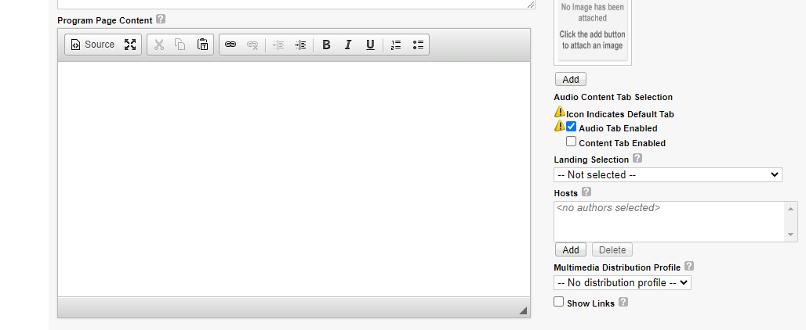
- Program Page Content: Provide more details about your show. It should be different from the podcast description. Take advantage of the space to include different keywords and links that make your podcast easier to find.
- Program Description is the podcast description that will be visible on the podcast platforms. The recommended length is 120 to 150 characters; don’t forget to include what the podcast is about, who the host(s) is, and how often it is published.
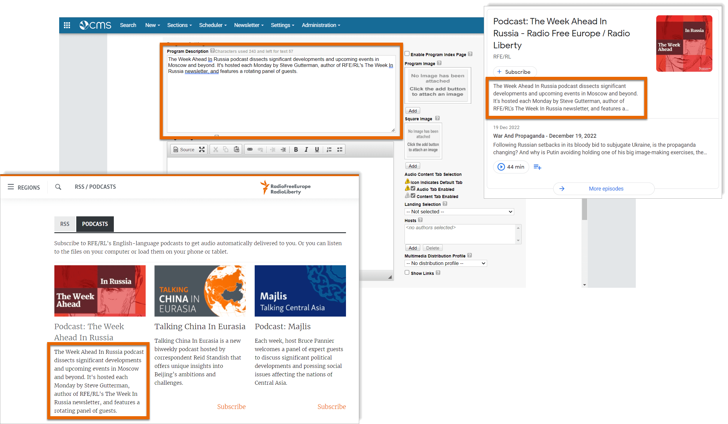
- Metadata you need to provide:
  - Meta title: Enter your podcast title without the word podcast
  - Meta description: Enter the same podcast description. This text is visible when your podcast appears in search results.
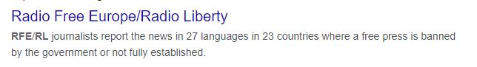
  - Meta keywords: Enter a collection of keywords that relates to the category.
- Category selection
To reach the best target audience for your podcast, it is important to classify it correctly into categories and subcategories in podcast platforms and applications.
Some apps, like Spotify, will offer their own list, but most apps will display the category you have chosen when setting up the podcast.
, When creating your podcast zone in Pangea, you should include the category as well. The list takes Apple podcast categories as a reference.
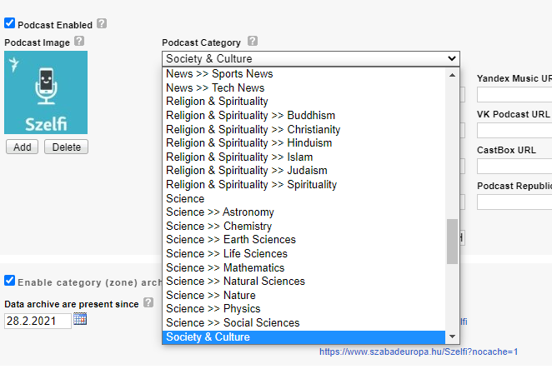

Once the zone is published, add your trailer as the first audio element of your feed (see the How-To in the next section). Once it’s published and appears in the feed, get the RSS link from the podcast website. Go to the subscribe button and copy the link.
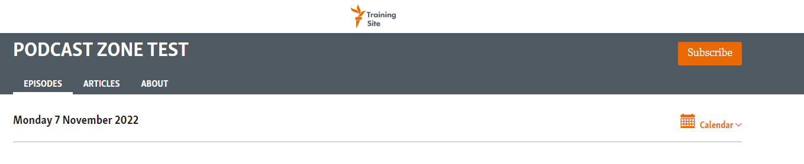
Send an e-mail with the RSS feed link and the name of your Service to the News Products Team (digitalstrategy@rferl.org). Specify in the subject “New podcast”.

Podcast custom URL
After you have created your podcast zone or section, you should define a custom URL (Obligatory).
A custom URL is a unique website address that is easier to remember, repeat and share. For example: www.szabadeuropa.hu/szelfi
For technical reasons, there are some reserved words you cannot include on your URL:
- Podcast
- Mobapp
- Api
- Rss
- Staticreport
If you use these words, your page will be unavailable.

How to create a custom URL:
After you have created your podcast zone and section, in Pangea CMS, go to settings > custom URL.
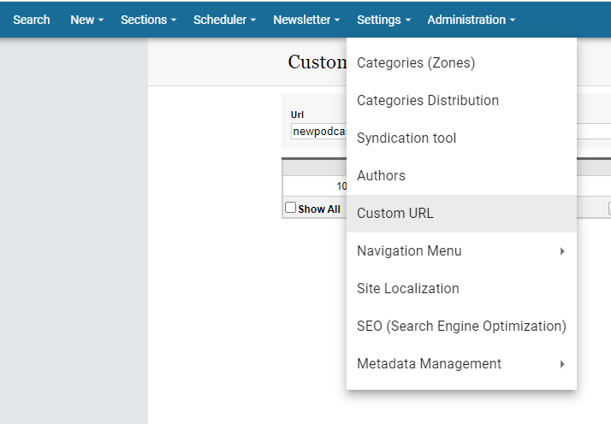
Go to new custom URL.
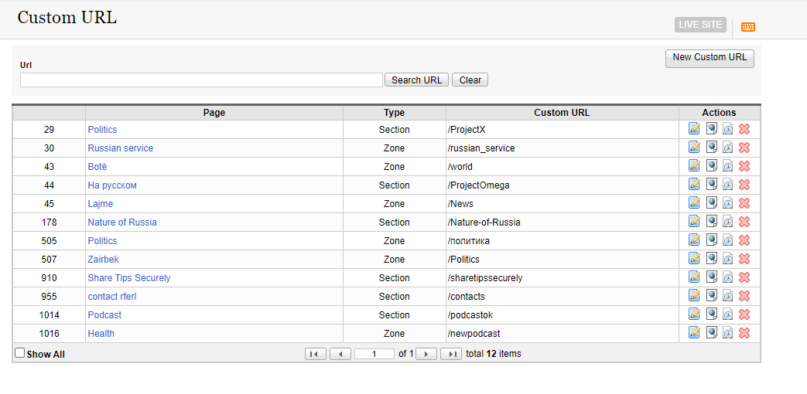

Write the name of your project (never a reserved word), link to zone or section, and select the zone it belongs to. Then save.
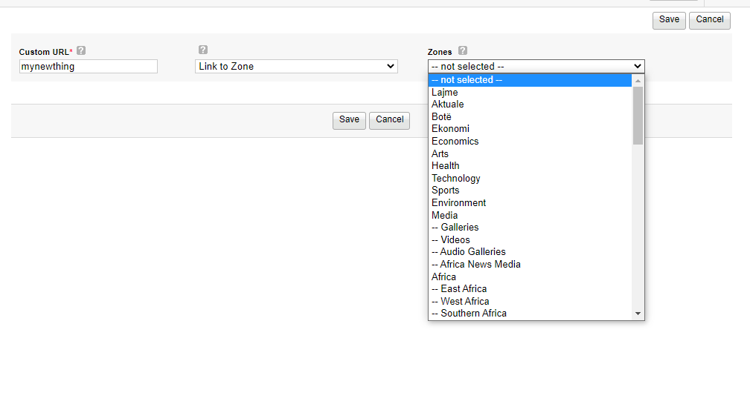
The result is a readable URL. If we follow the example, instead of having rferl.org/ddowru3402, you will have the URL rferl.org/mynewthing.

How to set up a new episode in Pangea
The team producing the podcast will set up the podcast episodes in Pangea. To upload a new episode in Pangea, go to Menu > New > Multimedia > Audio clip
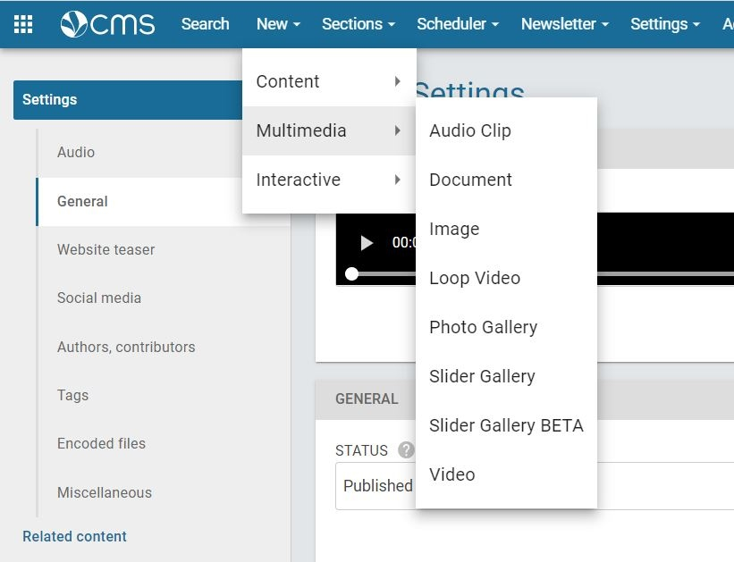

Drag and drop your audio file and fill in the following information:
- Title: Should add value and say what the episode is about, using keywords related to the topic.
- Introduction (aka description): Should include keywords (names, places, timely topics, and guests’ names) and be short (four sentences, max). Don’t repeat information from the title. Don't summarize or spoil the episode.
- URL slug: Include episode keywords to make it discoverable.
- Main image: Use a podcast or episode image. Whatever you use, be consistent and stick to your choice.
- Categories
- Content: Include the links to podcast platforms with a sentence like: “Listen to the podcast here or wherever you get your podcasts (Spotify, Apple Podcasts, Google Podcasts).” Each platform name should have a link to your podcast page in each of them.

External RSS feeds: Blockades
Apart from the Pangea-generated RSS feeds, editors are advised to use Buzzsprout, an external podcast hosting platform, when the RFE/RL feed is blocked.
❗️As it's an external service, please contact the News Products Team to set your podcast on Buzzsprout: digitalstrategy@rferl.org.
Blockades
When the Pangea-generated RSS feed is blocked, such as in Yandex Music, editors are advised to use Buzzsprout. Here is an example from Radio Svaboda: «КРАСАЎЦЫ» (here it is on Yandex Music).
Each Service, in coordination with the News Products Team, will upload the Buzzsprout RSS feed into the platform where the Pangea-generated feed is blocked.
The Pangea RSS feed will be uploaded to Spotify, Apple and Google Podcast. The Buzzsprout RSS feed will be used only on the platforms affected by the blockade.
*Author, e-mail, website link, language of the podcast, and location are generated automatically by Pangea. If we are setting up a podcast on a different podcast hosting platform, we need to fill in this information.

RSS specifications and changes
Here is an example of what each item in the RSS feed means and where it becomes visible or not visible for an audience accessing the podcast using Apple Podcasts.
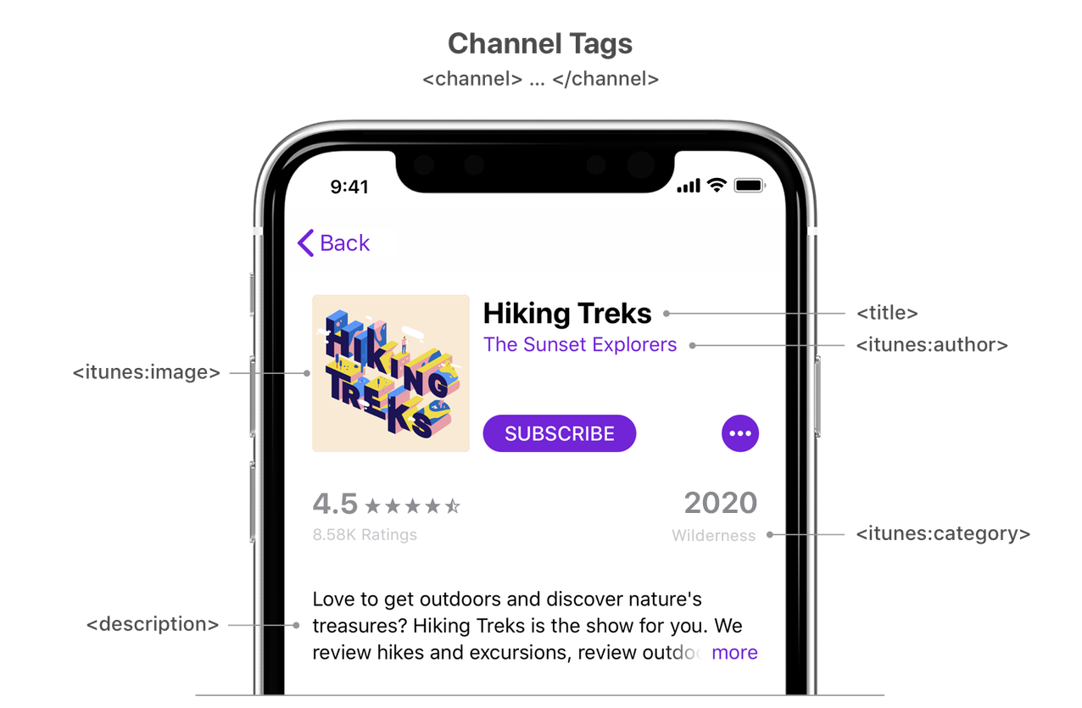

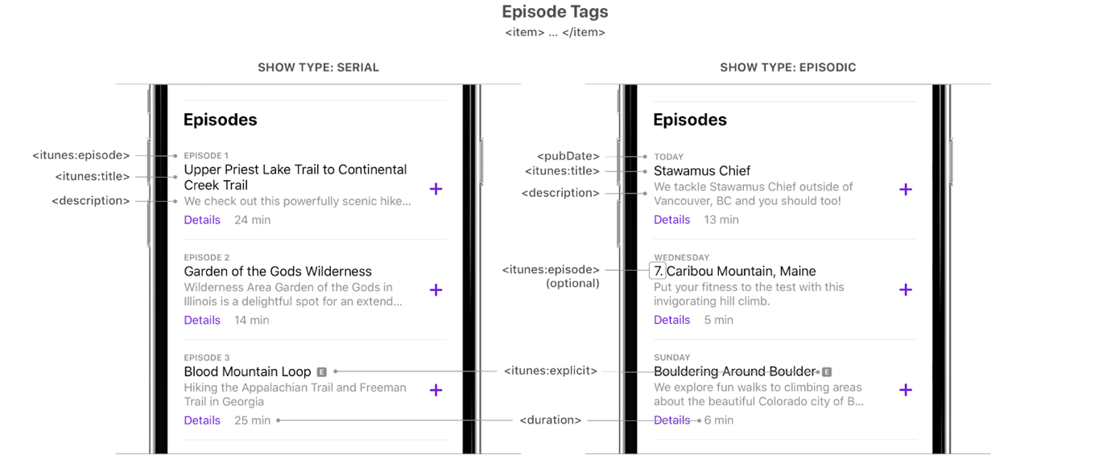

Changes in the RSS feed are led by the Pangea team, who has designed a roadmap and established the priorities. Some of the changes planned between December 2022 and February 2023 are:
- Episode images update
- Podcast tracking
- New podcast and episode types
Some other modifications expected soon:
Author
Each country/Service should have one and the same author and name filled in RSS for every podcast it creates, so that listeners can instantly identify podcasts in their native language just by looking at the author.
Pangea will work on RSS improvements. Services don't need to take any action.
E-mail address
Each Service should have its own e-mail, which the Pangea team will include in the RSS feed. This e-mail is used to claim the podcast in any Service connected to podcasting.
The e-mail can also be used by podcast hosts to connect with the audience and ask them to send feedback, questions, or other input. This e-mail (the one included in the RSS feed) is public and is regularly used by various parties to reach out to the podcast creators. Teams need to ensure the e-mail address is active and monitored.
To avoid any security risks, each Service should have a corporate e-mail specific and unique for podcasts. The idea is to have only one e-mail for all the actions and platforms–except Google–related to the podcast distribution process.
The e-mail structure might be something like: podcastradiofarda@rferl.org (podcastsservicename@rferl.org).
The News Products Team will define a roadmap to create and gather e-mail addresses from Services and deliver them to Pangea to add them into the RSS feeds.
To create a new e-mail address: Open a ticket, add the name or your e-mail, indicate that it's a shared inbox, and add the names of those people who need to access the inbox—namely the digital/audio lead and the teams involved in podcast/audio production.
After the e-mail is created, add the shared inbox to your personal inbox (O365).
If your team already has an account on external platforms, please contact the News Products Team (pedretalcarazc@rferl.org) to add the e-mail address into the podcast e-mail database.

Podcast distribution: Podcast platforms
The RSS feed of your new podcast needs to be submitted to the three big podcast platforms: Apple Podcasts, Spotify and Google Podcasts (see the how-to in the next section).
❗ ️The News Products Team will upload the RSS feed to external platforms (2-4 working days). This is a change in the podcast workflow.
The new process will be as follows:
You will need to publish your podcast zone and your trailer (Obligatory). Once the trailer is visible on the website, request the submission to external platforms by filling this form adding the RSS feed you will find on your podcast website.
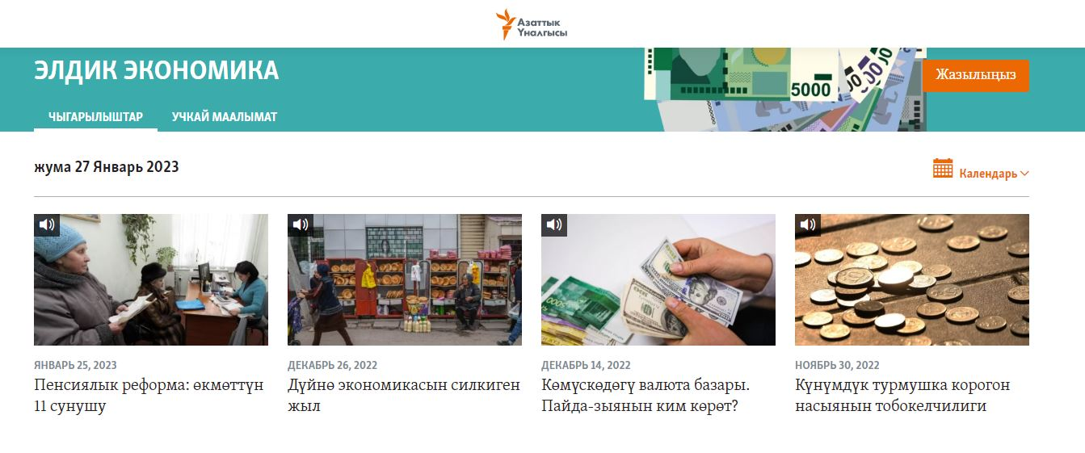
Next steps:
- The News Products Team will send the links to the digital/audio lead, who will add them to the podcast Pangea zone (2-4 working days).
- Once published on the RFE/RL website, the digital/audio lead will check that the links work and notify the team producing the podcast to trigger the promotion timeline.
The moment your podcast is on Apple Podcast, it will be replicated on other platforms that get their content from Apple. However, if there are specific platforms used in your country (Yandex Music, Castbox) then the digital/audio lead, with the approval of the Service Director, will specify them and notify the News Products Team to include them in the distribution plan.
The communication needs to happen before opening a profile in the platform or, if the Service already has one account, before adding the new podcast. The goal here is to be consistent about the platforms where users can find our content and that the News Products and Audience Teams can have control over our metrics.
Links to external platforms where the listener can tune in to your podcast must be included on the podcast website, articles and episodes.

Apple Podcasts
RFE/RL has a main account for Apple Podcasts which links all podcasts to the company. The goal is to make sure users can recognize RFE/RL podcasts as an entity, have better support from the platform, and reduce risks. It also allows better discovery of other podcasts from the same Service.
The News Products Team is the administrator of the Apple Podcasts master account and will submit the RSS feeds.
To preserve each team's unique character, this large group of podcasts is divided into “Channels” organized by Service. Listeners will have a chance to discover other podcasts from the same Service in a channel in their native language, without any other podcasts mixed in.
The News Products Team will create the channels and coordinate the migration with Services.
The channel will bear the name of the Service. For example, Radio Svaboda will have its own channel within Apple Podcasts and all the podcasts that are associated with the Service will be listed there.
Each channel will require specific artwork with a logo and the name of the service. Here you'll find Apple's specific requirements.
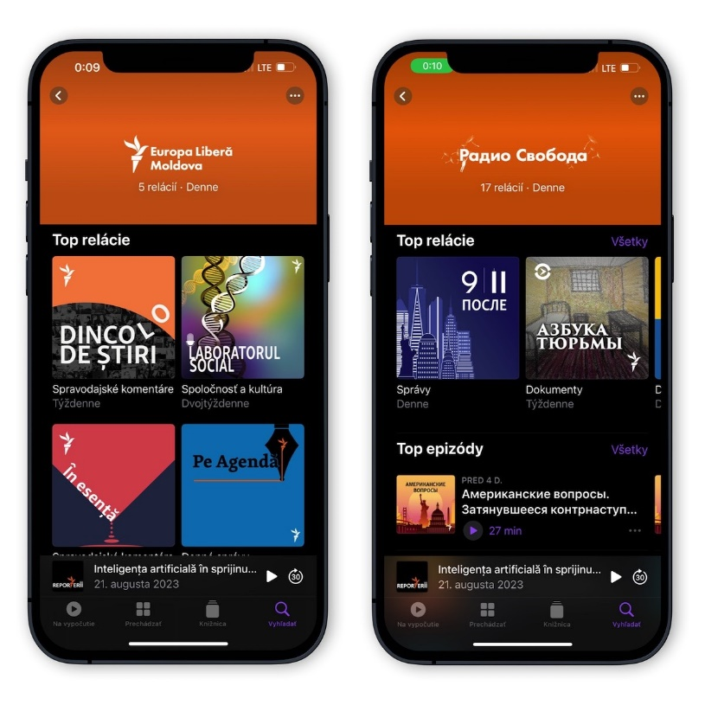

❗️The News Products Team will assist Services in the process and ask for a corporate image for each of the channels.

Spotify
To have a structure similar to Apple Podcasts, regarding Services having access to their podcasts only, the best way is to use the main Spotify for Podcasters account, where all RFE/RL podcasts will be claimed, and with access to all the data at once if needed.
The News Products Team will be the administrator of the master account.
Each Service should have a separate Spotify for Podcasters account with the name of the Service and claim only their podcasts. That means they will only see stats for their podcasts and the data would not mix between Services.
❗️ The News Products Team will assist teams to create their accounts and coordinate the process.
Next steps:
The News Products Team will:
- Define a roadmap to gain account governance.
- Claim podcasts from Services that already have a Spotify account.
- Assist Services in creating individual Spotify accounts (corporate e-mail).
- Assist Services in claiming their podcasts from the main RFE/RL account to individual ones.
As with Apple Podcasts, the RSS feed needs to be updated and include the Service name as an author.
Unfortunately, there is no way to replicate the channel function from Apple Podcasts Connect, which means that listeners would again have to identify podcasts in their native language by looking at the author. But once the authors of the RFE/RL podcasts are set correctly, there will be no confusion on the part of the audience.
How to create a Spotify for Podcasters account
- Sign up with Spotify for podcaster to create an account. Use your podcast corporate e-mail connected to a shared inbox, never Gmail or Facebook access.
- Use the name of your Service (What should we call you?).
- Use a strong password and keep login details in 1Password. If you don’t have corporate access, request it from the Service Desk.
Once the process is finished, you will automatically log in to the Spotify for Podcasters platform. To add or claim your podcast:
- Open the side menu by clicking on the three dots in the top left.
- Click Add or Claim podcast.
- Click Get Started.
- Paste in the link to your podcast's RSS feed.
- Spotify will send a verification e-mail to the address in your RSS feed. It should be one with a shared inbox.
- Copy the 8-digit code from that e-mail and paste in the submit form.
- Add podcast info like the category, language, and country.
- Review the details and submit.
- This is the link to be included into your podcast zone in Pangea.

Google Podcasts

*This workflow will change as Google podcast will shut down in 2024.
This setup is a mix of the previous setups. RFE/RL will have a master Google Podcasts account connected to a Gmail created by the News Products Team following advanced protection guidelines. There again, all RFE/RL podcasts should be claimed from the master account.
Apart from the master account, each Service should have its own Gmail account. Here is how to create one.
If the Service already has a Gmail account, teams need to validate access and credentials and keep login details in 1Password, including the mobile phone number associated with the account, so thatthe team always has access, and the phone's owner. If you don’t have corporate access to 1Password, request it from the Service Desk.
The name of the account will have a similar structure to the corporate e-mail account: Something like podcastradiofarda@gmail.com.
Google Podcasts will be the only platform with a different e-mail address; the rest will use the corporate e-mail created specifically for podcasts.
The News Products Team, as main admin of the Google Podcasts Manager, will grant Services access to see stats and data only for those podcasts they produce.
For Services that already have ownership of their podcasts, the News Products Team will coordinate the process to share ownership.
Next steps:
The News Products Team will:
- Create a Google master account.
- Claim RFE/RL podcasts without ownership.
- Create a roadmap for account setting (confirming existing Gmail accounts and access).
- Coordinate with Services that own RFE/RL podcasts under a Google account to claim ownership to the main account and give Services viewer role.
- Assist Services without a Google account to create one.
- Give viewer permission to Services with new Google accounts.

YouTube Podcasts
In the beginning of 2023, YouTube, the biggest video platform in the world added support for podcasts. The format has been already popular on the platform with various surveys like the Digital News Report claiming that more people listen to podcasts on YouTube than Apple Podcasts or even more than on Spotify (USA).
Now, YouTube only supports manual uploading of podcasts to the platform and each episode must be already made into a video (thanks to tools like Headliner you can do this with just a few clicks or even automate the whole process, see chapter ‘Audiograms for YouTube’).
The first step is to create a podcast playlist within YouTube (if you already have a playlist for podcasts you have been using, you can also easily change this into a podcast playlist in the settings on the playlist on YouTube).
Why is it important? YouTube will include your podcast in YouTube Music, add a special badge, spotlight it on its Podcasts page and recommend to new listeners with similar interests.
Luckily, YouTube has a whole explainer video about the process, if you want, you can watch that. You can also find YouTube’s guide on setting up podcasts on their YouTube Help web.
Alternatively, follow these steps:
- Within YouTube Studio, click Create > New podcast. You may be asked to verify your account before creating a new podcast.
- From the pop-up, select Create a new podcast. Select Set an existing playlist as a podcast if you’d like to turn an existing playlist into a podcast. Learn how to optimize existing playlists in the next section.
- Enter your podcast details, including:
- Podcast title
- Description
- Visibility (Public or Private)
- Square podcast thumbnail
- Click Create to save.
Once you’ve created your podcast, add episodes by uploading new or existing videos to your podcast.
Don’t forget to include links to other podcast platforms in the video description.

How to measure success
Submitting our podcast on external platforms is not the end of our job. The magic of digital formats is that we have a lot of information about our audiences. The level of granularity depends on the podcast platform, but some of them can tell us 'not only who is listening to what and for how long, but also where they are, what gender they are, or how old they are.
Depending on the stage of your podcast (launch or consolidation), you will focus more on one metric or on a combination of several.

Reach: having impact
Discoverability is one of the main challenges the podcast industry faces. The way podcasts are consumed is different from other digital products and, to have a better understanding of your performance, we need a bigger time frame to measure our reach.
- Unique listeners: How many people (devices) started an episode.
- Total plays for a 30-day period: How many times someone played or listened to the first seconds of an episode.
- Page views for articles about the podcast.
- Additional content: How many additional pieces were produced from podcast content.

Engagement: opening a conversation
This is about “quality time” with your audience and connection.
- Average time played (retention): Some platforms show it as minutes and others as a percentage.
- Average plays per episode (30/60-day period): This tells you which episodes are performing better when compared. Once you have several episodes published, this will give you information about the topics that matter most to your audience.
- Social media: Comments, views, likes, and shares related to your podcast content. When done correctly, the engagement rate of podcast listeners is higher than other formats.
- Reviews on podcast platforms.

Loyalty: building a relationship
- Subscribers/followers: People notified when a new episode is released. Don’t focus on the whole number, but on the percentage change.
- Average unique listeners per episode (30-day period): This number should be consistent and grow the more episodes you publish.

Key metrics to measure success
- Average time played (website, app and external platforms): It should be at least 40% of the episode. If that number represents less than 10% of your listeners, you need to rethink the structure of your podcast.
- Plays per episode in a 30-day period (website, app and external platforms): This is the only metric comparable on Spotify, Apple Podcasts and Google Podcasts.
    - 1,000 = the minimum average for monetization.
    - 500 = you are on the right track.
    - < 80 = low engagement.
- Subscribers/followers: total number grows consistently.
A bad performance should not hold you back. Instead, use this information to know your audience better and improve your podcasts to meet their needs and answer their questions.

Checklist: Podcast promotion and marketing
Your podcast promotion is based on making the most of the content you have produced. All the elements are essential (Obligatory), unless specified otherwise.
Most of the elements on the checklist refer to each new episode.
Text
Before launch, you will need:
- An explainer on how to listen to a podcast (one template per Service).
- An article about the launch of your new podcast with the trailer embedded.
After launch:
- One article per episode with the audio episode embedded.
- Episode transcription with the episode embedded. If you use a transcription tool (see Transcription section), the text will have to be reviewed and edited.
*Ideally both options (Advanced), but if your team does not have enough resources, choose at least one and stick to it until the end of the season.
Social media profiles that might help you spread the word (all platforms):
Ask them to be part of your promotion strategy.
- Podcast host personal profile/s
- Your Service social media accounts
- RFE/RL journalists related to the topic of the podcast and/or a particular episode
- Your podcast guests
Social media content to share:
- Audio episode link. You can share the link with the metadata visible and/or the link with a picture of the topic.
- Article’s link with your episode embedded.
- Audiogram (a clip from the episode turned into a short video, ideal for Reels, Shorts, TikTok...). (Advanced)
- Quote cards (a quote or thought from the podcast on a thumbnail with the author and podcast logo). (Advanced)
Cross promotion:
Think about other digital products of your Service that share a target audience or are topic related and promote your podcast there. The key here is to think of the connection between products and audiences.
Choose at least one of the following options:
- Promotional message (30 seconds max) at the beginning of an existing podcast of your Service.
- Interview with the new podcast host on a podcast that is already “on air”.
- New podcast first episode as part of an episode of an existing podcast. This needs some context from the existing podcast host.
- Mention of the new podcast in newsletters that share a target audience and language.
- Articles about a topic related to the new podcast where a banner or a link to the podcast can be included.
Audiograms (More on Audiograms for social media)
Check guidelines on how to use audiograms and templates. Entire episodes will only be published as audiograms on YouTube.
- Full trailer
- An extract from an episode (30-60 seconds). It can be a quote, a sequence, a funny moment, best moment/s, etc. (Advanced)
- YouTube episode (only if YouTube is part of your distribution strategy)
Video (Advanced)
Video is a great way to promote your podcast as it has broader reach than audiograms. However, you will need more resources.
This is not about publishing your podcast audio with random images, but about creating a video that has its own narrative structure and will work as a video on its own.
- Trailer (video version)
- Podcast episodes (video podcast)
- YouTube episode (only if YouTube is part of your distribution strategy)
This is an example of a video podcast published on YouTube: ПАДКАСТ «КРАСАЎЦЫ»

Pod Cards (O)
These are images of your podcast logo or of a single episode. You can use them to promote your show on social media or in your newsletter (banner).
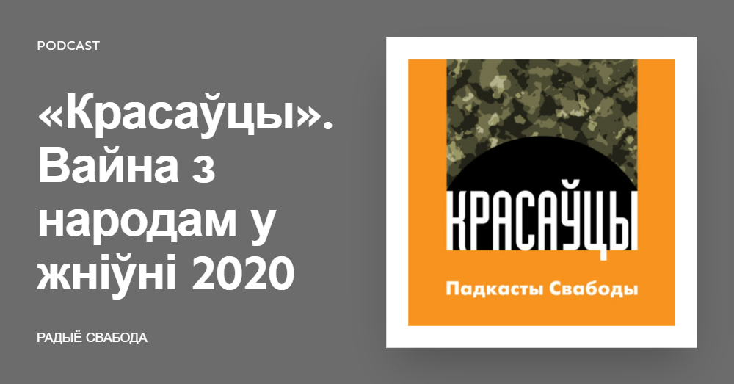
Pod Cards is a free online service you can use to create cards in a matter of seconds. No login required. Although easy, you need to use the cards in moderation or you will fill your social media timeline with repetitive images.
- Rule: One pod card for every five posts about your podcast on social media.
Podcast platforms have their own services to produce cards. If you want to use the card offered by a platform, you will need to use both:
  - Promo cards - A promo image creator for your podcast by Spotify.
  - Social Post Generator - A promo image creator for your podcast by Apple Podcasts.
Publication calendar
Consider creating a publication calendar to promote your podcast. Bear in mind your audience’s habits, such as when they are online, and change the day and time when you share content about your podcast to reach different people.
Don’t forget to include evergreen content in your overall strategy to promote your Service’s podcast.
Download and save the calendar spreadsheet. (Change the distribution of columns and rows to make it yours.)

Audiograms for social media
An audiogram is a file that combines visual art, a sound wave, an audio track, and a transcription of the audio file. Audiograms help us overcome two problems with audio formats: shareability and discoverability.
Except for YouTube and the podcast trailer, audiograms last max 60 seconds.

When to use audiograms?
- Quotes: Interviews, experts or witnesses from podcasts or newsy stories.
- Storytelling: Exclusive stories, podcast sequences, or special events we only have as an audio file. If we have video, it's always better to share the video. In these cases, audiograms might need to be longer.
- Podcast promotion: Trailer and best moment/s (Ex: A funny or remarkable sequence from our podcast. Example).
- Podcast episodes: Only for YouTube.
The easiest way to produce audiograms is to use the online editing tool Headliner. Basic accounts are free, but the News Products Team will set PRO accounts for those Services requiring it.
To have a Headliner PRO account:
- Open a basic account. We recommend doing it with an e-mail from a shared inbox—ideally the e-mail address from your podcast shared inbox. That will grant more members of your team access to the account. Don’t use the Google option, but a corporate e-mail.
- Keep the password in 1Password and share the vault with your team members. If you don’t have corporate access, request it from the Service Desk.
- Once your basic Headliner account is open, send an e-mail or a Teams message to Carla Pedret pedretalcarazc@rferl.org for final account setting.
Templates
The Pangea Design Team has created some templates for audiograms that consider:
- Aspect ratio of each platform
- Image size related to the content, or the person quoted.
Templates will be distributed among Services with guidelines on how to use them properly. The News Products Team and the Pangea Design Team will assist in the rollout.

How to create an audiogram
A guide to create audiograms using Headliner for shorter audio clips (up to 10 minutes).
Headliner step-by-step video tutorial.
Step 1: Log in and select manual audiograms > up to 10 minutes.
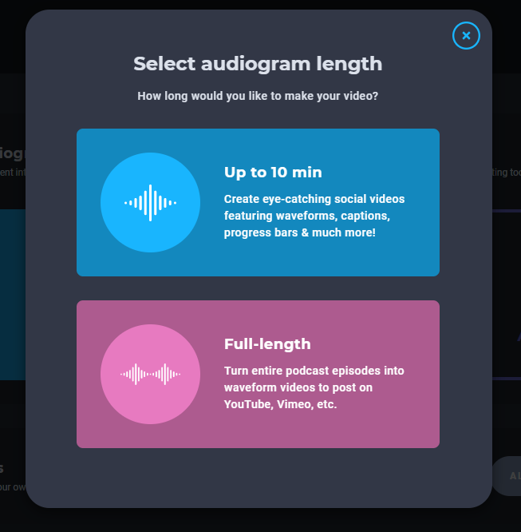
Step 2: Upload the clip from your podcast episode (mp3 or wav). You can also upload the entire episode and select a snippet using the Headliner edition tool.
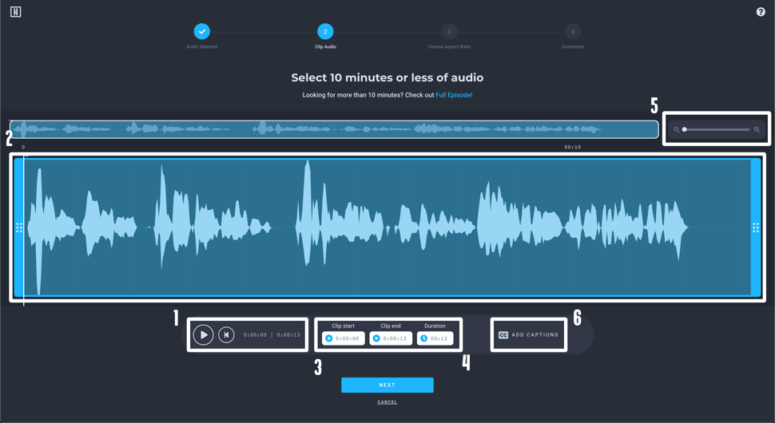
You can select your clip by scrubbing through and listening to your episode (1) and by dragging the blue highlighted selection (2). You can pick your audio’s in/out points by clicking and dragging on the edges of the highlighted blue selection; or by entering a timecode on the lower left side of the clipper (3); or by inputing a duration from the lower right side of the clipper (4). Additionally, you can zoom in to help refine your selection by using our zoom option (5).
After you’ve selected your clip, you can enable captions for your selection from under the clipper (6) before hitting next. Click and select transcription language. Then click next.
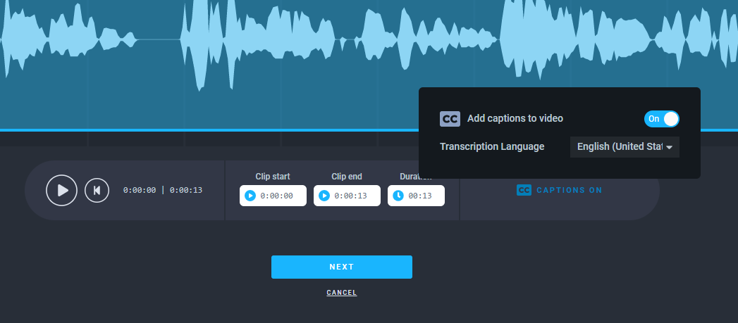
Step 3: Choose the aspect ratio.
- Landscape: Best for YouTube.
- Square: Best for social media newsfeeds: Instagram, Twitter, Facebook, and LinkedIn.
- Portrait: Best for Instagram Stories, YouTube Shorts, and TikTok.
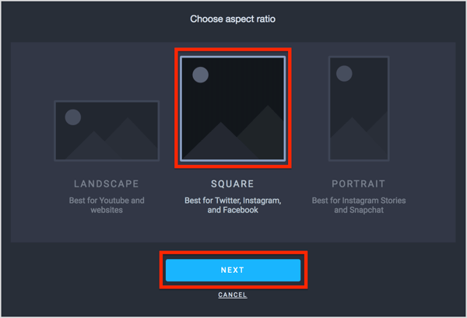
Step 4: Access one of the templates made by the Pangea Design Team.
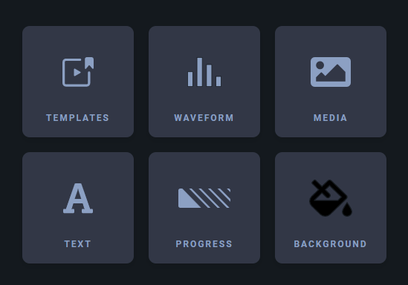
Step 5: Customize your audiogram.
Follow Pangea Design Team recommendations on color, waveform, and wave and caption's location.
Step 6: Name your project and open advance editor.
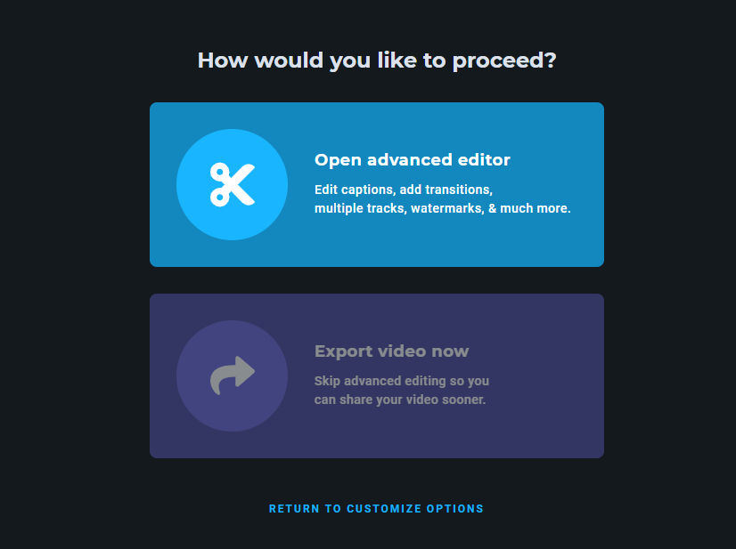
Step 7: Use the editor to correct transcription errors and review your audiogram. You can change the capture features by selecting the A from the menu.
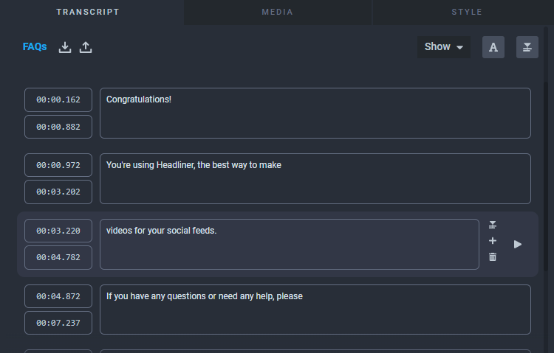
Clicking into the tracks, on the lower part of the screen you will find other text and image properties.
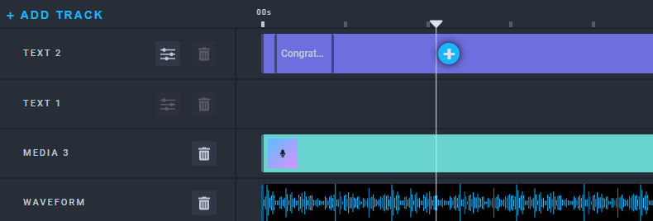
Step 8: Add your e-mail and/or the e-mail of your team members. Leave the default values and export your audiogram. You will receive an e-mail when the process is finished.
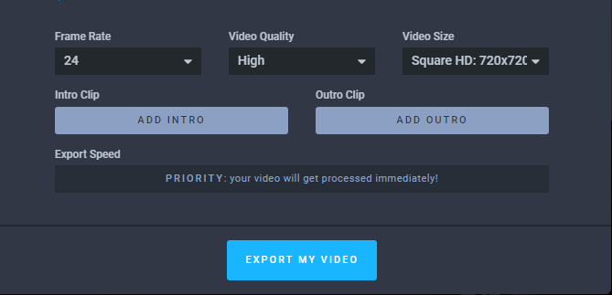
Step 9: Don't share your audiogram on social media using the icons from the menu. Download the audiogram (an mp4 file) and upload it directly onto the platform you want to use. Pay attention to the aspect ratio.
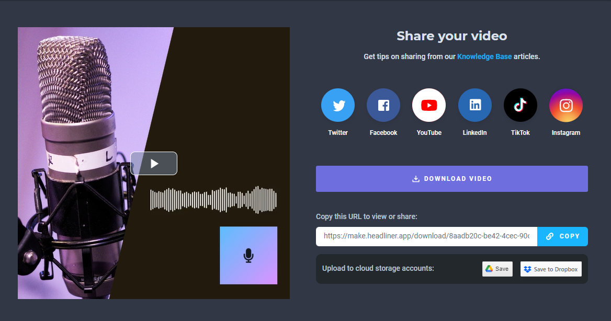

Audiograms for YouTube
Thanks to tools that let us easily convert whole podcast episodes—even two-hour-long ones—into videos, we recommend taking advantage of this feature. YouTube is the second-largest search engine and probably the biggest platform, where billions of people come to discover new content to consume.
The Digital News Report 2022 found that in some countries, YouTube is more popular for podcast listening than are some podcast players. Google Podcasts, for example, tends to underperform YouTube when it comes to audience growth and overall size.

Setting up automatic audio posting on YouTube
Headliner lets you set up an automatic posting of new podcast episodes to a YouTube channel. For this purpose, we recommend a separate YouTube channel where you don’t post video-first content. Of course, you can use the main channel.
! Before starting the process, you should ask the News Products Team for visual recommendations and guidelines in using this type of automation.
Here are all the steps you need to set it up and some recommended settings:
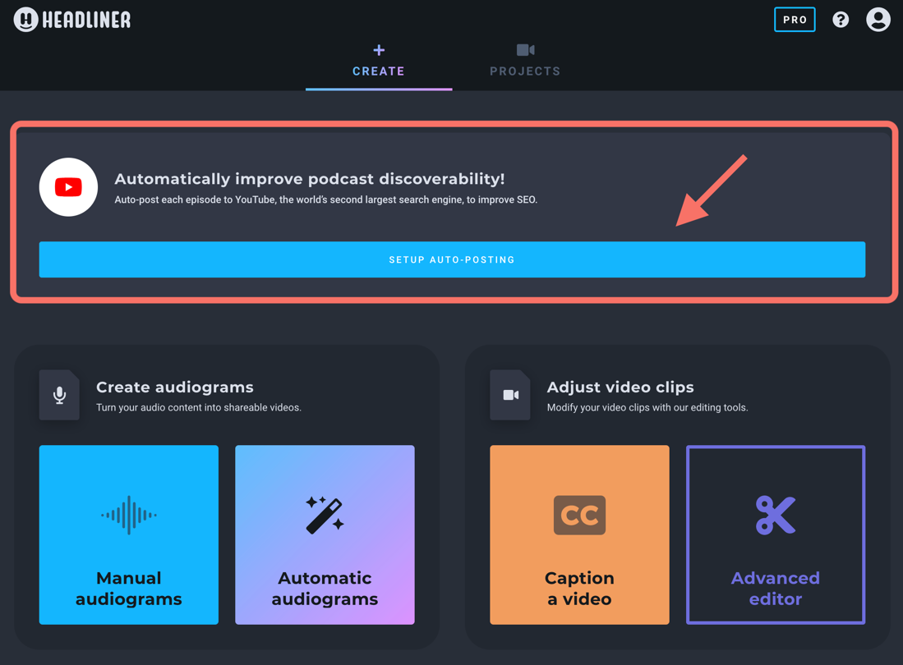
Select auto-posting and then find your podcast in the catalogue or insert your podcast’s RSS feed.
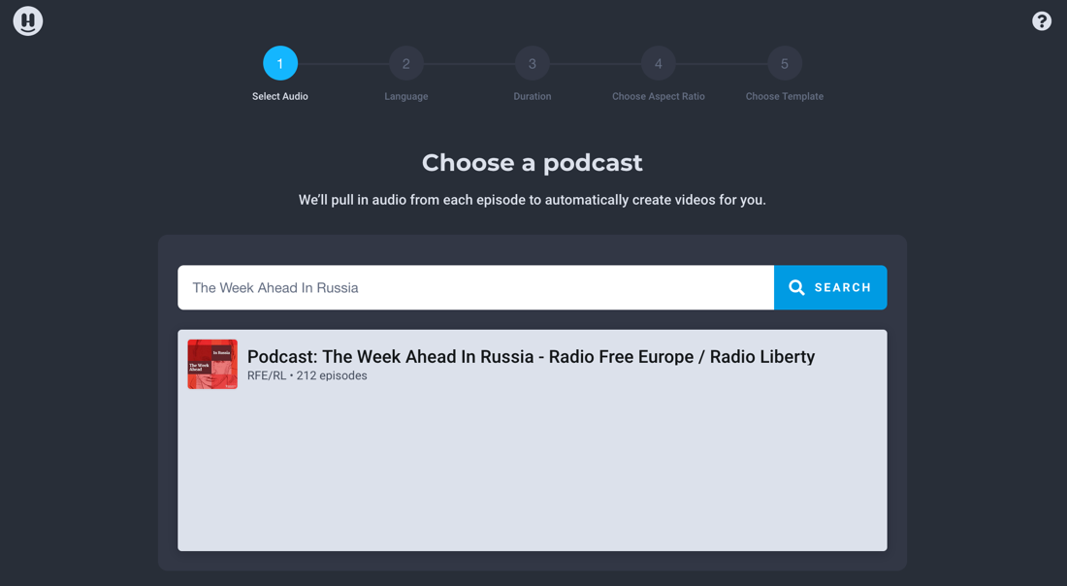
Next, choose the language of the podcast; the right one should be pre-selected. Choose that you want to auto-post whole episodes, not clips.
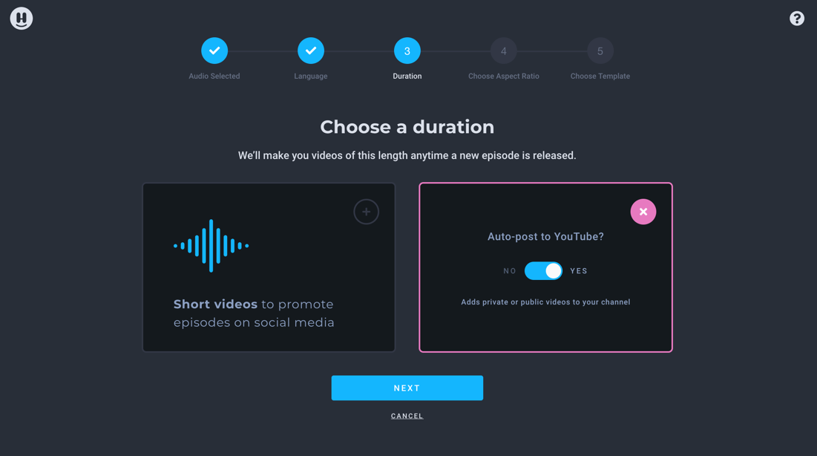
Then link your YouTube account to Headliner and grant permission to manage the account and post videos.
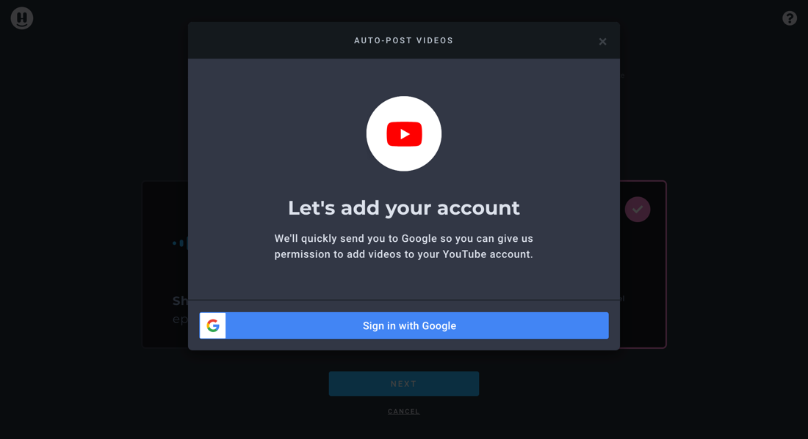
You will have to edit the default version of the video metadata. See below for the recommended edit:
- The episode title should be first. Put the podcast title in brackets.
- In the description, put the episode description, links to the podcast on podcast platforms, links to social media accounts, and a link to your newsletter if you have one.
- Also, include hashtags like the podcast topic, #podcast and perhaps the title of the podcast as a hashtag.
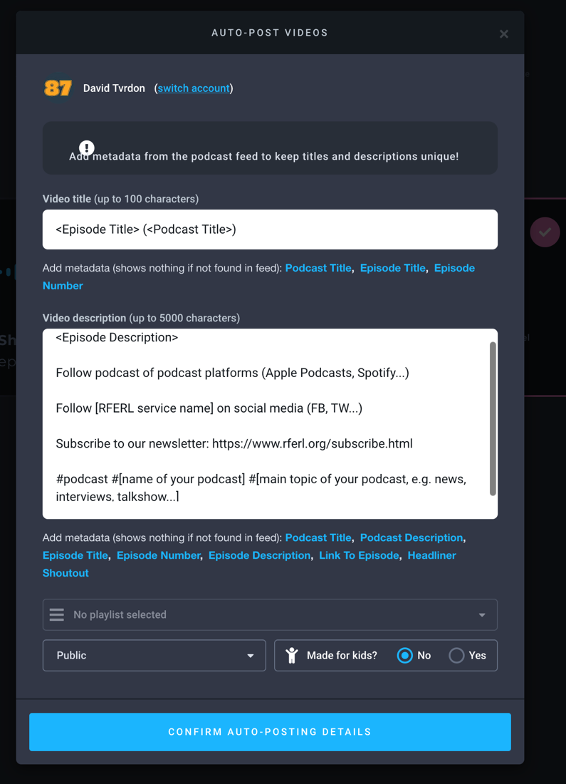
Choose the aspect ratio and then choose a template if you already saved one, or create a new one, ideally one you have prepared beforehand.
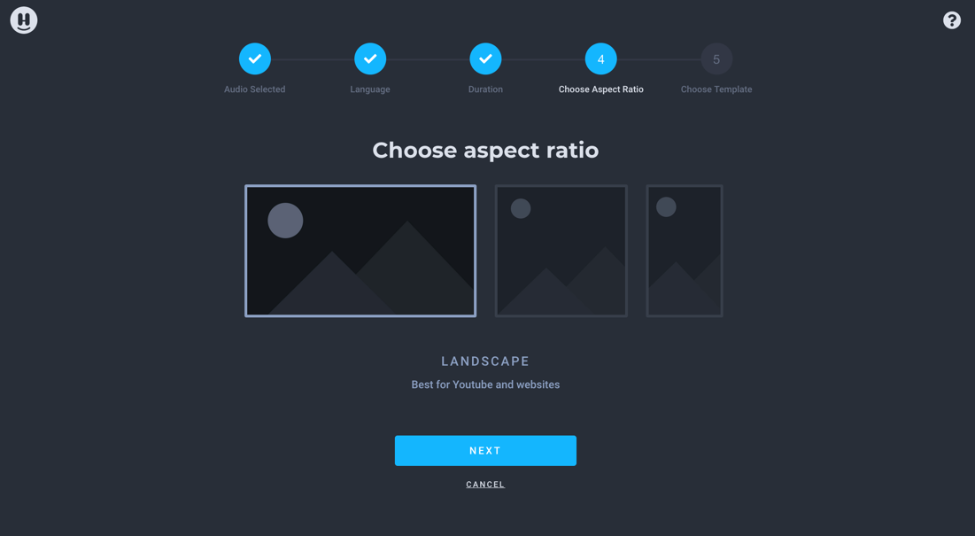
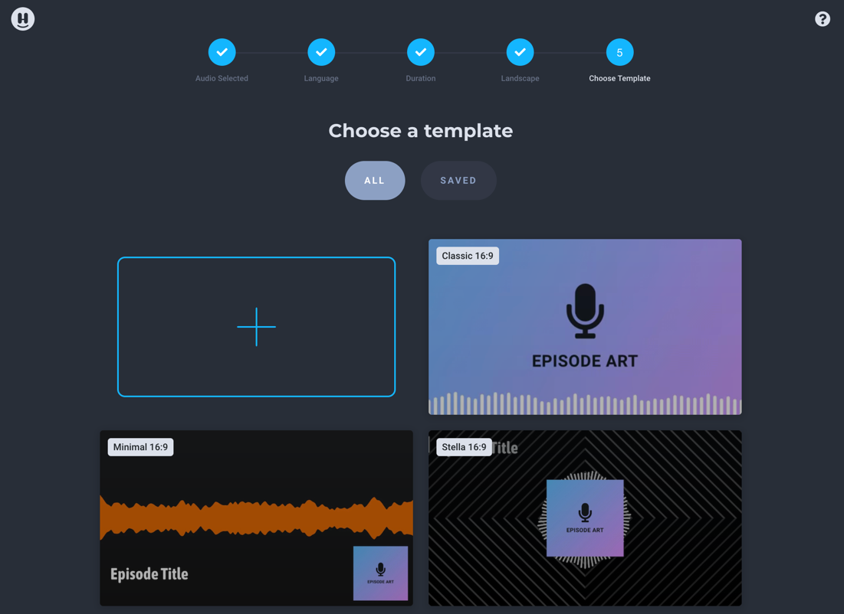
And your automation is ready and set.
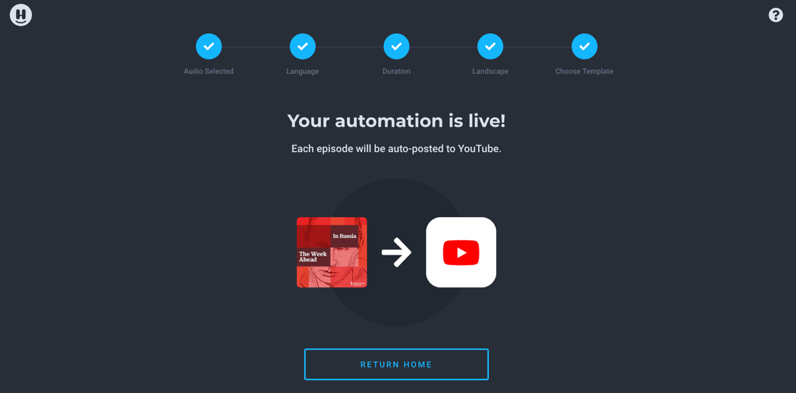
If you want to delete an automation, go into the Projects tab and hover over the podcast logo in the left. Hit the “Delete” button when it appears.
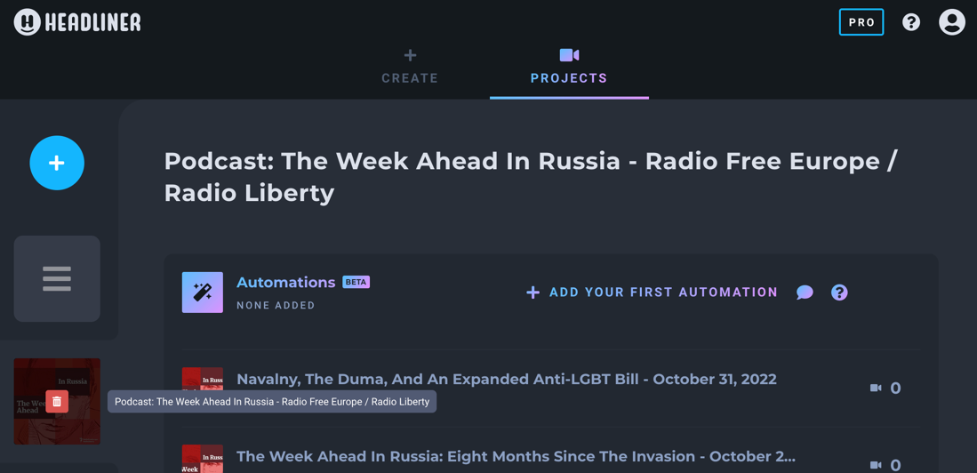

Spotify engagement tools for podcasts
Since 2023, Spotify make Q&A and polls available for content creators via the Spotify for Podcasters dashboard for every podcast even if they are not hosted on Spotify.
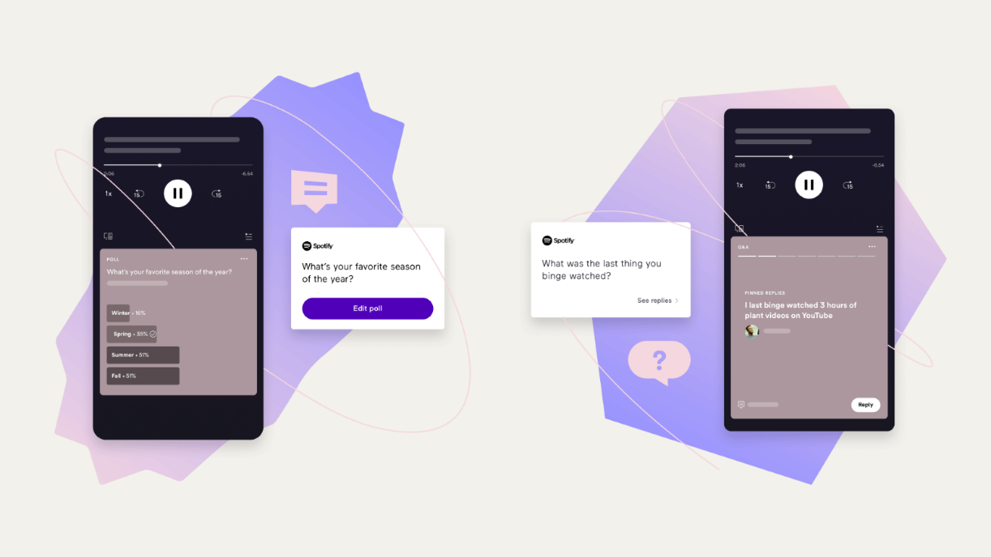
Spotify has a whole tutorial on its website, here is a basic guide:
Log in to Spotify for Podcasters website; the Interact tab is the place to create, edit, and manage listener feedback across your show. You can select an episode to add a Q&A or poll, then simply press the plus icon (+) to draft it. Once you’re done writing your Q&A or poll, tap ‘Save’ to make it live.
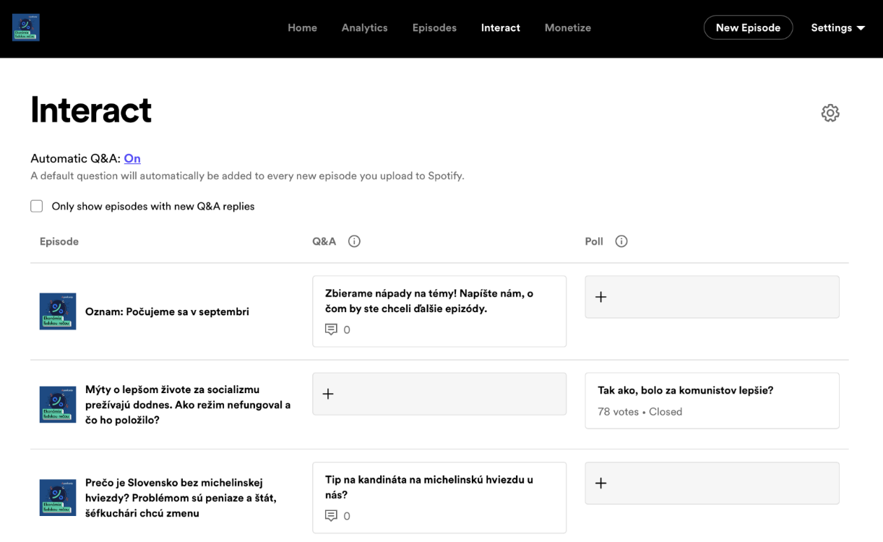
Q&A responses are private by default. When you have responses, you’d like to be public on Spotify, you have to publish them first. Just navigate to any Q&A to see the replies and tap the “publish” button so they are visible on your episode page.
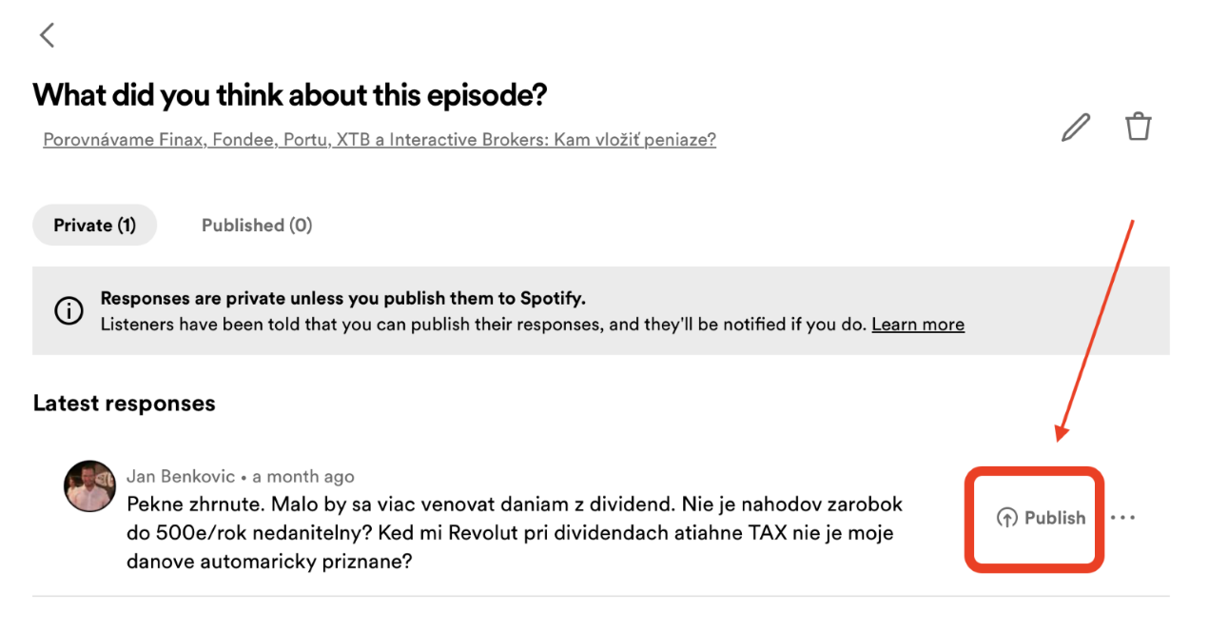
Creating polls is simple. Just add your question and create up to seven options for your listeners to choose from (you can even choose between single select or allow listeners to select multiple options).
You can control how long the poll runs for; the real-time responses will display during that time frame, and the final results will appear on your episode page after it closes.
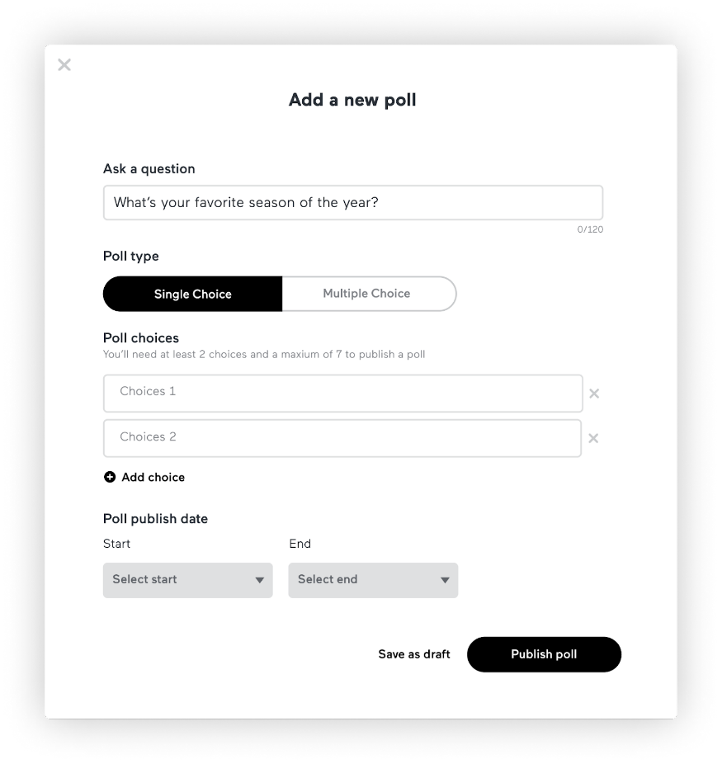
As Spotify rightly notes in its tutorial, audience engagement tears down the limitations placed on the podcast format since its inception. Whereas before, podcasting was mostly output and little input, now creators can have a real exchange with their audience.
Spotify also put together a list of Q&A and polls inspiration you can start off with:
- On average, would you say you listen to your favorite podcasts at home or on the go? [poll]
- Where do you most often listen to podcasts? [Q&A]
- Since the start of the pandemic, do you find that you’re listening to podcasts more, less, or about the same? [poll]
- What’s your social media platform of choice? [poll]
- How long is the ideal episode? [Q&A]
- Besides my show, of course, what’s your go-to podcast? [Q&A]
- What could I be doing better? [Q&A]
- Are you a podcaster yourself? [poll]
- What’s your favorite podcast genre? [Q&A]
- Which type of podcast do you prefer: topical commentary, nonfiction narrative, scripted fiction, self-help, interview, or freeform/hybrid? [poll]
- How did you first find out about my show? [Q&A]
- What’s the ideal day of the week for a new episode to drop? [poll]
- Have you ever recommended my podcast to a friend? [poll]
- How would you describe my content to someone who’s never listened? [Q&A]

Outdated podcasts: what to do?
There are nearly five milion podcasts out there, so building an audience takes time. Good content and consistency are key. Your podcasts are part of the broader strategy of your Service. When considering new ideas or radio programs suitable for a podcast, think strategically and long term.
The content that works best is regular–listening becomes a daily or weekly habit– serialized–listeners want to know how the story ends–or evergreen–it’s relevant over time.
Deleting or hiding a podcast is possible, but not straightforward. Apple Podcasts is the only one that allows creators to have some control. For Spotify, you must contact them via e-mail with a request to remove each podcast. Google podcast demands a more technical solution and takes 3-4 weeks.
Based on this Playbook criteria, Services are encouraged to revise their podcast catalogue and reorganize their offerings to focus on:
- Podcast audience compared to other Service podcasts.
- Target audience and outcome.
- Alignment of the project with the Service’s goals and action items.
- Resources invested: Time, teams, etc.
- Last episode date.
- Workflow: Alternative products that might be developed if the podcast is cancelled.
! If the numbers are unsatisfactory, try promoting the show again before deleting the content. Follow the steps described in the promotion section. It's important to set a time frame for the promotion—how long is it going to last—and KPI (Key Performance Indicators) to analyze the results and make a final decision.
If, after the review and new promotion strategy, Service Directors decide to delete some podcasts from external platforms, they should send an e-mail to the News Products Team (digitalstrategy@rferl.org) who will start the process. The e-mail should contain:
- Podcast name
- RSS feed
- Service name
- Why the content must be deleted

Podcast landing page: How to set it in Pangea
If you have a podcast portfolio, you should have an overall podcast landing page.
This landing page should showcase all the podcasts of your Service. The overall landing page can serve to link in primary surfaces on the site, be shared on social media, and be promoted in your messaging platforms.
Most Services have a podcast landing page, but it is advised to apply this layout. The main difference is that users can listen to the last episode from the landing page without clicking again, which reduces friction.
.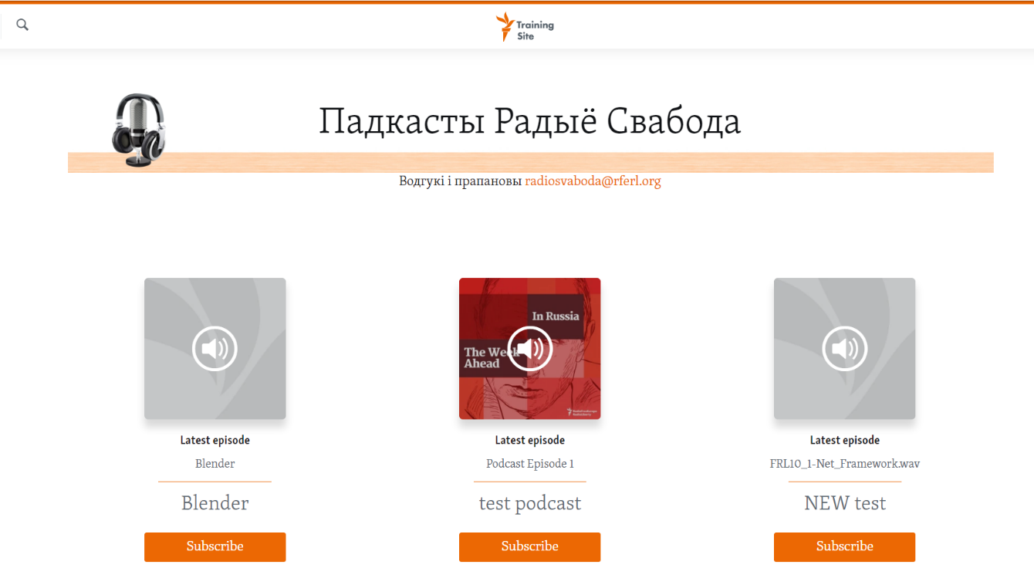

How to create a podcast landing page
1. Setup
Create a landing page that will hold podcast widgets. Under Sections, create a new landing page.
2. Layout
Your top element should be a one-column content holder that will hold the main header.
The header should have the following text: Name of your Service podcasts.
Ex: Radio Farda podcasts
Open a ticket with the Pangea Design Team to request an image for your header. Services with an image like the one in the example are encouraged to change it.
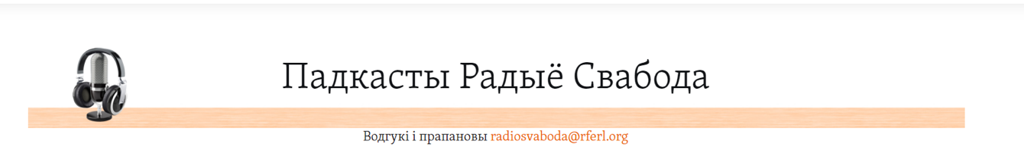
Depending on how many podcasts you have, you need to consider the layout.
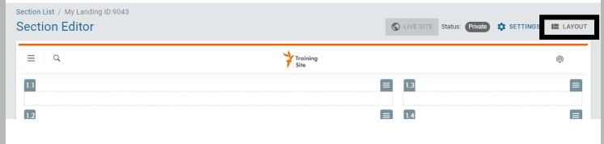
On a landing page you want to place the podcast widget equally. Consider the number of podcasts and design the layout according to your needs.
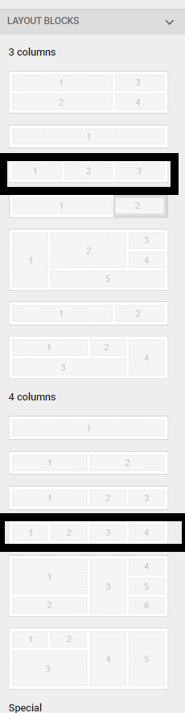

A possible look for three or more podcasts is the following. A single podcast would be placed in the middle.
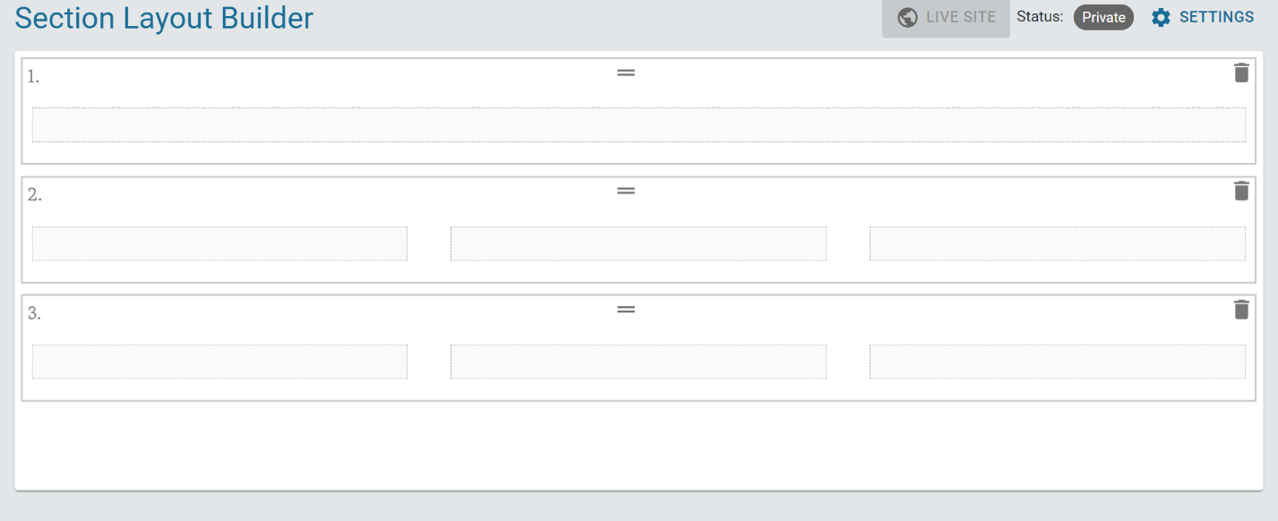
Once complete, please go to the Section Editor.
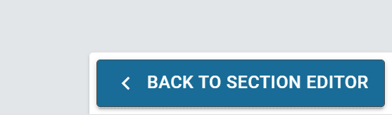

3. Add podcast to widget
In the Section Editor, place the podcast widget.
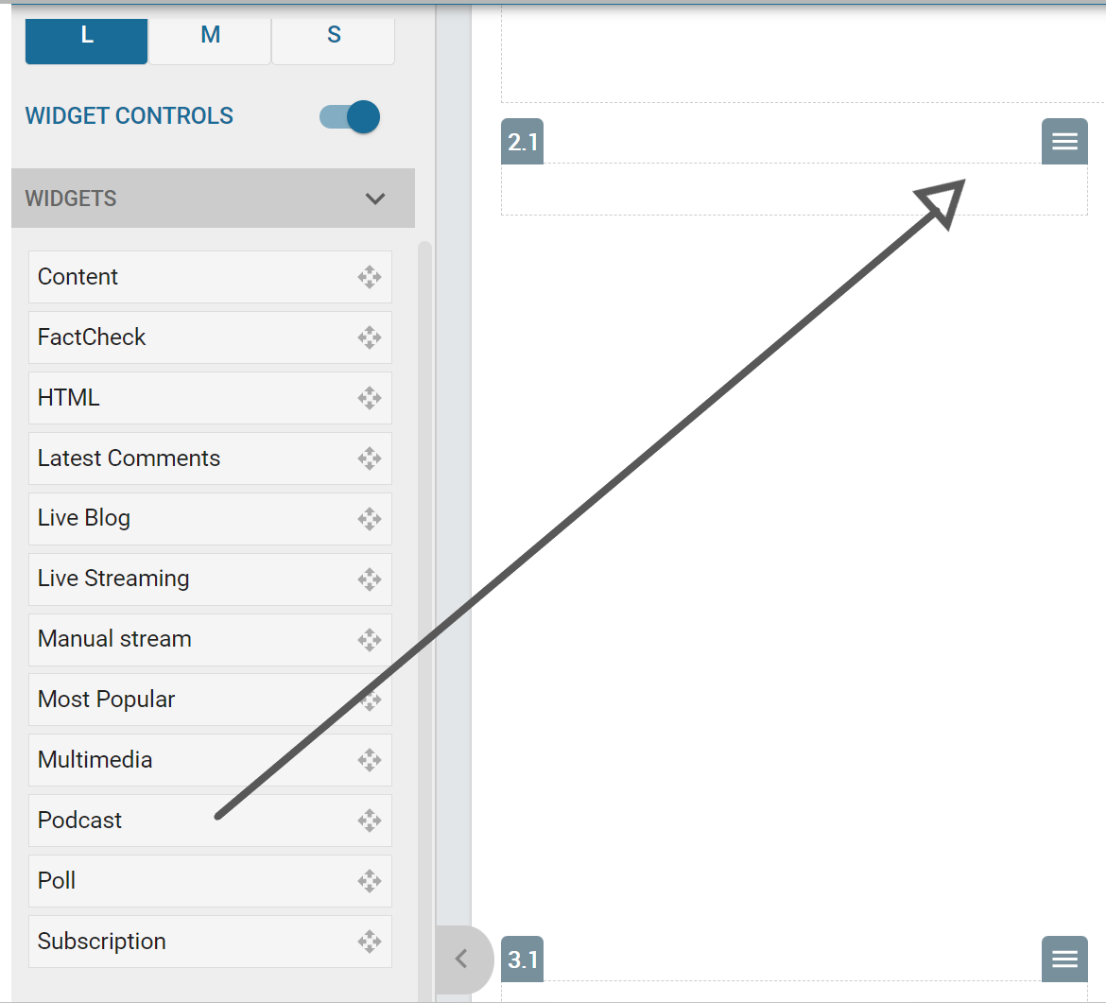
4. Setting the podcast
- Choose No title
- Choose the podcast that should be in the widget.
- Choose the standard layout
- Click Save
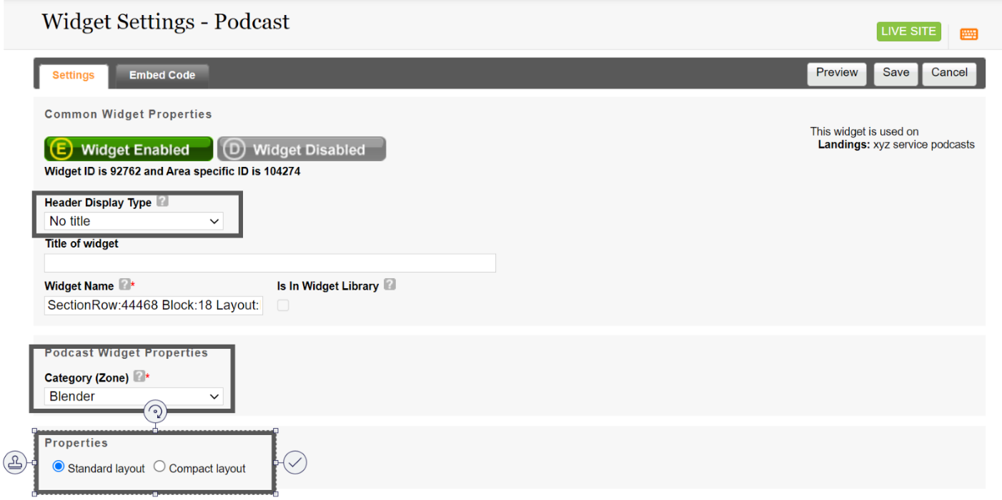
When you are happy with your layout go to Settings.
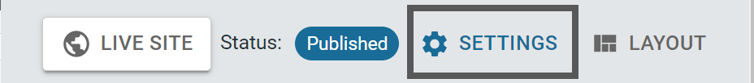
Fill out:
- Localize title
- English title
- Meta title: Name of your Service podcasts. Ex: Radio Farda podcasts (max 70 characters)
- Meta description: This is what appears under your name in searches. It summarizes the page content and what the page is about (max 157 characters). You can see a draft version using this tool.
- Meta keywords: Include words related to the page, separated by a comma: podcast, your country, Service name, etc.
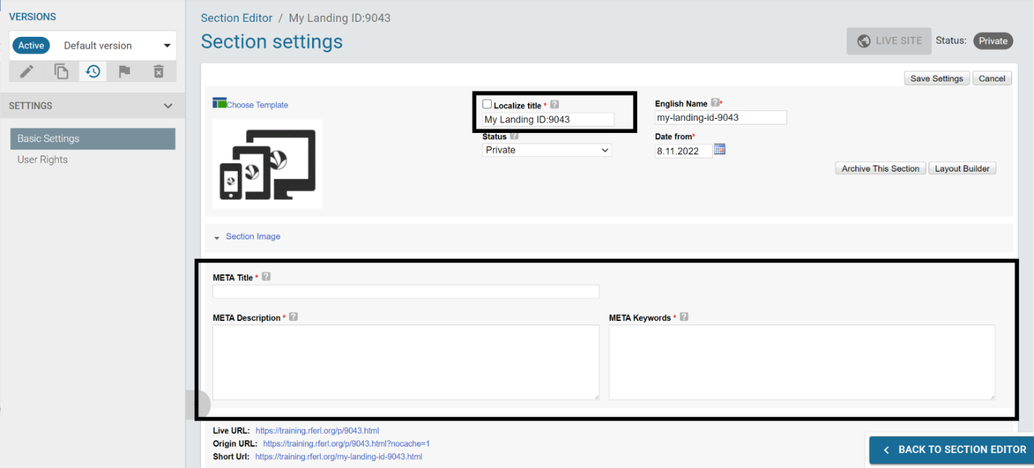
Once ready, set the page to public and save settings. Your new podcast landing page is published.

Audience survey questions
Audience research is one of the best ways to get to know your audience. Below are questions that can help you quickly put together a listener survey. Similar questions are used in many respected podcast audience listener reports; if you follow the questions below, you will have the opportunity to compare your data with that from other countries or regions.
Based on the Edison Research Podcast Listener Survey.

Show Listening Habits
Determine how long and how often respondents are listening to the show.
Do you listen to…?
- Every episode of [INSERT PODCAST NAME]
- Almost every episode of [INSERT PODCAST NAME]
- Select episodes of [INSERT PODCAST NAME]
How long have you been listening to [INSERT PODCAST NAME]?
- Less than six months
- Six months to less than one year
- One year to less than three years
- Three years to less than five years
- Five years or more
In general, how soon do you typically listen to an episode of [INSERT PODCAST NAME] after its release?
- The same day
- Within 48 hours
- Within a week
- More than a week after
- Don’t know
In general, how often would you like episodes of [INSERT PODCAST NAME] to come out?
- Every day
- Once a week
- Once every two weeks
- Once every month
- No set schedule
- No preference
In general, do you think each episode of [INSERT PODCAST NAME] should be…?
- Longer
- Shorter
- Same length

Listener Engagement
Determine how respondents discovered the show and how they engage with it.
How did you first discover [INSERT PODCAST NAME]?
- Through a recommendation from friends or family
- Through a recommendation from another audio program host
- Through an app that provides personalized recommendations
- A mention on another podcast
- By searching the internet
- Through push notifications from a podcast app
- By hearing some or all of the podcast on another podcast
- By reading about it in an article
- By browsing an app you use to listen to podcasts
- Social media posts
- Through YouTube
- Through some other way (specify: ______________)
Do you follow or subscribe to [INSERT PODCAST NAME] in order to know when new episodes are released?
- Yes
- No
Besides listening, how else do you interact with [INSERT PODCAST NAME]? Mark all that apply.
- Through the show’s official social media accounts
- I follow [INSERT RFE/RL SERVICE NAME] on social media
- I follow the host(s) on their personal social media accounts
- I get the newsletter update by e-mail
- Attend events
- None of the above

Listening Locations and Platforms
Determine where respondents listen to the show.
Where do you listen most often to [INSERT PODCAST NAME]?
- At home
- At work
- In a car or truck
- While riding public transportation
- At a gym or while working out
- While walking around or on foot
- Someplace else (specify: _____________)
Which of the following apps or services do you use most often to listen to [INSERT PODCAST NAME]?
- Spotify
- Apple Podcasts
- Google Podcasts
- YouTube
- Podcast Addict
- Castbox
- Pocket Casts
- SoundCloud
- The podcast's own website
- Someplace else (specify: _____________)

Episodes and Elements
Gauge respondent reaction to show elements, recurring guests and specific episodes.
How would you rate the following about [INSERT PODCAST NAME]?
Really dislike – 1 - 2 - 3 - 4 - 5—Really like
- The host(s) personality
- The interaction and flow between host and guests
- Audio/sound quality
- The music or theme
- Length of the show
- How frequently the show is released
Who was your favorite guest on [INSERT PODCAST NAME]?
[INSERT NAMES OF GUESTS]
Why was that your favorite guest? ________________________________________________
Who was your least favorite guest on [INSERT PODCAST NAME]?
[INSERT NAMES OF GUESTS]
Why was that your least favorite guest? ____________________________________________
In general, do you think [INSERT PODCAST NAME] is getting better, worse, or has it stayed the same?
- It is getting better
- It is getting worse
- It has stayed the same
Please elaborate on why you feel that way. __________________________________________

General Podcast Listening
Determine what topic areas respondents have an interest in and what other podcasts they listen to.
In general, what topics do you enjoy listening to on podcasts? Mark all that apply.
- Adult
- Biography/Memoir
- Business
- Comedy
- Children’s
- Drama
- Entertainment, celebrity, and gossip
- Food
- Fantasy/Sci-fi
- Games/Hobbies
- History
- Home/Garden
- Language
- Music
- Mystery/Thriller
- News/Information
- Philosophy/Religion
- Romance
- Science
- Sport
- Technology
- Travel
- True Crime
- Wellness/Self-improvement
- Politics
- Other _____________________
What other podcasts do you listen to?
________________________________________________________________________
Which of the following podcasts do you ever listen to? Mark all that apply.
[INSERT NAMES OF OTHER PODCASTS]

Demographics
All the remaining questions are behavioral or demographic. While this information can be valuable when approaching advertisers, you do NOT need it to analyze the results of the survey.
Do you currently ever use any of the following services? Mark all that apply.
- Facebook
- LinkedIn
- Instagram
- Twitter
- Snapchat
- WhatsApp
- TikTok
- Clubhouse
- Pinterest
- Reddit
- None of the above

How old are you? ________
- Prefer not to answer

With which gender do you identify?
- Male
- Female
- Non-binary
- Other: ____________
- Prefer not to answer
Do you have any children living with you who are:
- No, I don’t have any children
- Under 5 years old
- 5-12 years old
- 13-17 years old
- Prefer not to answer

Which country are you currently living in? ____________
What is the highest level of education you have completed?
- Less than 12th grade
- High school graduate or GED
- Some college, including associate degree
- College graduate/Bachelor’s degree
- Graduate or post-grad
- Prefer not to answer

